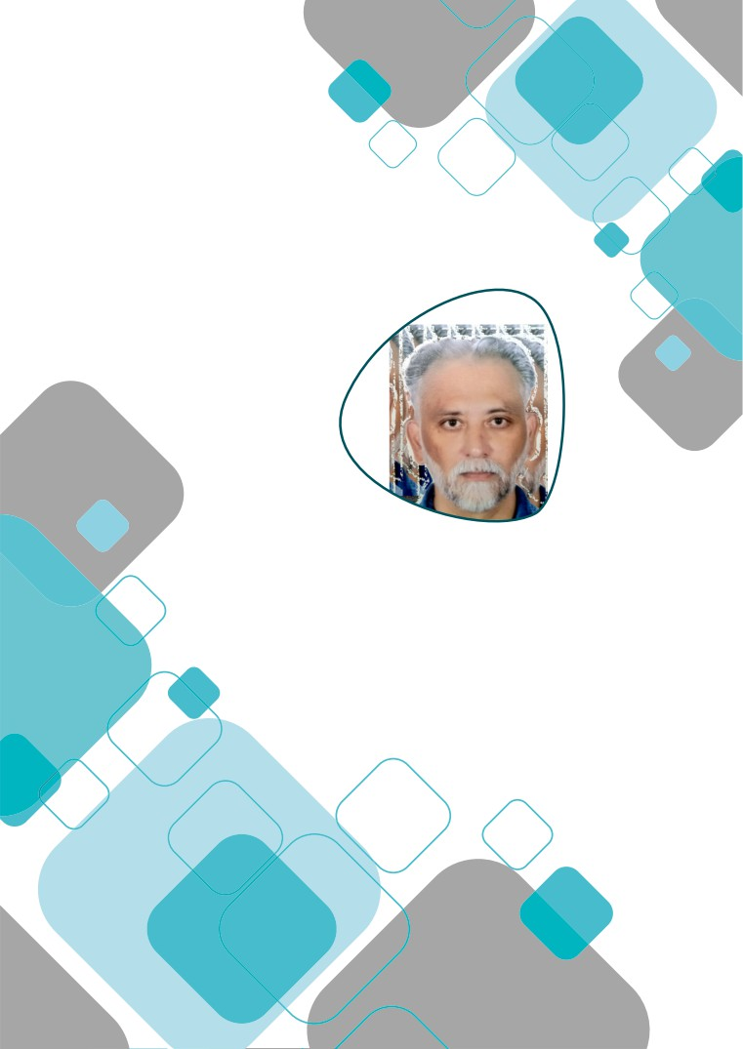

APPLICATION FOR SHRI RAM LAL AGRAWAL GOLD MEDAL – 2020;2021;2022

Submitted by

Dr. Gautam Ramkrishna Bhojne
Assistant Professor
Department of Clinical Veterinary Medicine, Ethics & Jurisprudence
Nagpur Veterinary College, Nagpur

Dr. Gautam Ramkrishna Bhojne

+919822360475
drbhojne@gmail.com; bhojne_goutam@rediffmail.com
Office:
Dept. of Veterinary Clinical Medicine, Ethics & Jurisprudence, Nagpur Veterinary College,
Seminary Hills, Nagpur - 440006 (M.S.)
Home:
100, Mona Bright House, Hanuman nagar, Nagpur - 440 009
Date of Birth
15th October, 1971 (Annexure – I)
ISVM Membership No. ISVM/LM/A 323 Annexure-II)

ACADEMIC AND RESEARCH ACHIEVEMENTS
Academic Record (Annexure - III)

Degree Year University CGPA Distinction

B.V.Sc. & A.H. 1995
M.V.Sc. (Medicine) 1997
Ph.D. 2016
Dr. P. D. K. V., Akola 7.29 -

st
Dr. P. D. K. V., Akola 8.58 1 with Distinction
MAFSU, Nagpur 8.53 -

Training/Summer Institutes (Annexure - IV)

Sr. Title of Course Duration Name of Organizing
No. Insittute

1. Health Management of Wild Animals

2. Maharashtra State Certificate Course of
Information Technology
3. Administrative Training Programme
4. Office Administration and Accounts
Procedure

5. Updates in Veterinary Internal Medicine

6. Epidemiological surveillance and
investigation of disease
7. Workshop cum Training program on
Biochemical Research Techniques: Free radicals and scavengers in Health and Diseases.
27th Nov. to 8th Wildlife Institute of India,
Dec. 2000 Dehradun
3 months in 2003 Nagpur Veterinary College,
Nagpur
3-7th Feb., 2004 MAFSU, Nagpur
24th March 2007 Vasantrao Naik State
Agriculture Extension Management Training Institute, Nagpur.
5th to 25th TANUVAS, Chennai November, 2008
7th to 11th Le Meridian hotel, Nagpur November, 2016
15th to 24th March University Department of
2017 Biochemistry, RTMNU,
Nagpur

1

Sr. Title of Course Duration Name of Organizing
No. Insittute

8. Workshop cum Training program on
Research Methodology Technology Platforms
and Orientation Programme for research in
Molecular Biology, Bioinformatics and CADD
9. Massive Open Online Course (MOOC) on
Teaching Management

10. Massive Open Online Course (MOOC) on
Dynamics of Teaching-Learning .
7th to 21st Jan. University Department of
2019 Biochemistry, RTMNU,
Nagpur

1-30 Nov.2017 ICAR-National Academy of
Agriculture Research Management.
Rajendranagar, Hyderabad

1-30 Nov.2018 ICAR-National Academy of
Agriculture Research Management.
Rajendranagar, Hyderabad

11. 5th Massive Open Online Course (MOOC) 1-30 Nov 2019 MANAGE, NAARM,
on “Teaching Excellence” Hyderabad(A.P.)

12. Massive Open Online Course (MOOC) on 1-15 May 2020 MANAGE, NAARM,
“Psychology of learning” Hyderabad(A.P.)
13. Massive Open Online Course (MOOC) 1-31 July 2020 MANAGE, NAARM,
on “Designing E-Learning Content” Hyderabad(A.P.)

14. International e-Training cum Orientation 5-25 Jul 2022 COVAS,Mhow.
Programme on “Technology Advancement and
Integration in Improving Animal Health,
Production and Reproduction vis-à- vis Climate Change”

Academic Experience
UG Teaching: 16 years
PG Teaching: 16 years

Courses Taught
- B.V. Sc.: VMD-421; VMD-511; VCM-421; VCM-422; VCM-511; VCM-512 ;VCM-513; VAC-421;
VCP-411; VCP-421; VCP-511;TVC-421
- M.V.Sc.: VCM-602;VCM-604; VCM-605; VCM-608; VCM-609; VCM-611; VCM-612; VCM-613;
VCM-615; VCM-691;VCM-612
- Ph.D: VCM-709; VCM-710;VCM-711

P. G. student guided
Guided 08 (Eight) P. G. students as a major advisor and acted as member of advisory committee of 25(Twenty Five) P. G. students. Member of Advisory Committee of Two Ph.D student.

Teaching Aids:
Prepared various attractive charts/ S0P's depicting laboratory techniques / Power point presentations of UG / PG Courses.

Laboratory facilities created:
As a course teacher established laboratory for the Department of Clinical Medicine and created facilities for imparting practical of UG students and research work of PG students.
Established Rumenology laboratory under National Innovation Foundation,Ahemadabad for herbal drug validation in bloat condition.

Practical Manuals:
Prepared practical manual for 3 courses as VCP 411, VCP 421 and VCP 511 for UG courses and Practical manuals of PG courses. Practical Manual For Veterinary Medicine Paper-I (MSVE-2016)

Lecture notes:
Prepared lecture notes for various courses of clinical medicine.

Teaching method:
After making several experiments, adopted / developed improved teaching methods which are based on equal involvement of teacher and student in teaching process. This is again based on principle that teaching merely does not mean conducting lecture for 1 - 2 hrs. in classroom/ laboratory as per schedule but it include all efforts made for overall development of students. The salient features of teaching method followed are:
- Through preparation of lecture
- Updating and simplifying lecture notes from time to time

2

- Giving more practical and applied information
- Involving students in classroom, laboratory and clinical camps Ÿ Completion of syllabus well in advance
- Making all round efforts to develop sincerity, obedience, honesty, ability to work hard discipline and regularity among students.

Research Experience- Thesis/Dissertations
Masters Research:
Electrocardiographic evaluation in senile dogs.

Doctoral Research:
Etio - pathophysiological basis for characterization of renal defects in canine and their medical management
Research/Clinical article published in Journals:
Published 102 research /clinical articles in national and international journals.
Research topics on which appreciable work is done:
a. Wildlife health and management
b. Standardization and efficacy of herbal medicaments
c. Canine electrocardiography
d. Canine Haemodialysis

Research Schemes Completed (Annexure - V)

(Amount in Rs.)

Sr. Name of the Scheme Budget Year Funding Agency
No.
1. Mechanization of experimental plots 38,09,000 2004 NATP-MM
2. Integrated densified total mixed ration 1,00,00,000 2004 IDTMR
3. Evaluation of Anthelminthic Properties 1,46,050 2012 NIF, Ahmadabad
4. Evaluation of Bloat Formulation 5,72,700 2013 NIF, Ahmadabad

5.
Efficacy of Herbal Galactogogue on Milk Production in Cows & Buffaloes

1,75,000 2013
Chemicals India Pvt. Ltd., New Delhi

6.
Evaluation of Unique Medication Against Bloat in Goat

51,600 2013 NIF, Ahmadabad

7. Large Animal Ambulance Facility 1,20,00,000 2014 Govt. of Maharashtra
8. Evaluation of Bloat Formulation 7,61,280 2013 NIF, Ahmadabad
9. Evaluation of Galactogouge Property 1,50,000 2013 NIF, Ahmadabad
10. Critical Care Unit 90,00,000 2011 ICAR, New Delhi
11. Wildlife Research & Training Centre 18,73,00,000 2014 FDCM

3

Sr. Name of the Scheme Budget Year Funding Agency
No.

12. Establishment of community based
Animal Husbandry Practice in Tribal
nd
36,33,000 2014 Tribal Sub Plan

Villages of Gadchiroli District, 2 year
awaited under tribal plan of Maharashtra
state.
13. Strengthening and Modernization of TVCC 6,00,000,00 2011 Rashtriya Krishi Vikas
of Nagpur Veterinary College, Nagpur Yojana
14. Evaluation of Bloat Formulations 2,64,000 2018 National Innovation
Foundation
15. Clinical evaluation of indigenous 8,47,000 2019 National Innovation
medications against mastitis & tick Foundation
infestation among farm animals
EMPLOYMENT RECORD
Sr. Post Held Name of the Employer Period
No.
1. Senior Research Fellow Dept. of Medicine, 6/1/2000 to
Nagpur Veterinary College, Nagpur 28/2/2002
2. Farm Superintendent Maharashtra Animal & Fishery 1/3/2002 to
Cattle Breeding Farm N. V. C., Sciences University, Nagpur. 7/4/2006
Nagpur
3. Technical Officer Maharashtra Animal & Fishery 7/4/2006 to
Sciences University, Nagpur 14/9/2006
4. Assistant Professor Maharashtra Animal & Fishery 15/9/2006
Clinical Veterinary Medicine, Sciences University, Nagpur To till date
Ethics and Jurisprudence

INTERNATIONAL, NATIONAL AWARDS RECEIVED
National Awards
Dr. Babasaheb Ambedkar Fellowship Award, New Delhi on 7th July 2010.
ISVM Awards
a) Certificate of merit for second prize for best oral presentation during National symposium of
ISVM and XXII Annual convection at IVRI, Izatnagar in 2004.
b) Certificate of merit for Poster presentation on Hypoparathyroidism in Leopard at 29th Annual
convection and National symposium of ISVM at Mumbai in 2011.
c) IIIrd oral Presentation Prize in session of Ethnoveterinary and Intregrative Veterinary
Medicine at the 32nd Annual Convention of ISVM and International Symposium on the “ the
21st century road map for veterinary Practice, Education and Research in India and
developing countries at Division of Vety. Medicine,” held at Sher-e-Kashmir University of Agri.
Sciences and Technology of Jammu, R.S. Pura from 14-16th February, 2014.

4

Honors/Recognition
1. Appreciation letter from Conservator of Forest (Wildlife) Nagpur, Nov. 2001.
2. Commendation certificate from Indian association of Vety. Public Health specialists for
service rendered, 2003.
3. SanmanPatra' from People for Animals, Vidharbha Chapter, Nagpur.
4. Appreciation certificate from Maharashtra Animal & Fishery Sciences University.2003
5. Letter of Appreciation for active participation as a Judge in catwalk: Fashion show organized
on the eve of World Animal Day, on 3rd October 2004 at Nagpur
6. Appreciation letter from Indian society for animal human welfare, 30th January, 2005. 7. Appreciation letter from Asian congress on canine practice February 7-9, 2007.
8. Award & Felicitation for Outstanding Contribution in the field of Nature and Wildlife
Conservation from Conservator of Forests & Field Director, Pench Tiger Reserve, Nagpur
(M.S.) on 7th October, 2007
9. Letter of Appreciation from Baba Ameteji 29th March 2007.
10. Letter of appreciation from DI and Dean Faculty of Vety. Science, MAFSU, Nagpur 29th
February, 2008.
11. Vidarbha stariya Dr. Babasaheb Ambedkar Samaj sevak Puraskar, 2009.
12. Certificate of Appreciation from Registrar MAFSU, Nagpur 20.12.2008.
13. Letter of appreciation from Registrar and DI and Dean faculty of Vety. Science, MAFSU,
Nagpur 22nd January, 2010.
14. Award & Certificate of appreciation. Government of Maharashtra, Nagpur Forest Division,
Nagpur.For actively participation of rescue operation of a leopard from a house at Vela
Village 0n 26th Feb.2011.
15. Certificate for conducting workshop cum training on “ MAN -WILD ANIMAL CONFLICT”
Government of Maharashtra, Department of Forest, Office of the Dy. Conservator of Forests,
Melghat Tiger Project, Sipna Wildlife Division, Paratwada from 10th June,2011 at Semadoh,
Dist. Amravati.
16. Certificate of appreciation & Felicitation. Government of Maharashtra, Chandrapur Forest
Division, Chandrapur for Outstanding Contribution in the field of Nature and Wildlife 30 July
2011.
17. Award & Felicitation by Government of Maharashtra for exemplary services rendered in
assisting the wildlife wing in rescuing , treating the injured tiger caught from Ghondmodi
Village of Chandrapur by Principal Chief Conservator of Forests Wildlife & Chief Wildlife
Warden. Maharashtra State.on 7th October, 2012.
18. Felicitation by Hon'ble Maneka Gandhi, National President, People for Animals for
Outstanding Contribution in treating the stray animals on 29th April 2013.
19. IIIrd oral Presentation Prize in session of Ethnoveterinary and Intregrative Veterinary
Medicine at the 32nd Annual Convention of ISVM and International Symposium on the “ the
21st century road map for veterinary Practice, Education and Research in India and

5

developing countries at Division of Vety. Medicine,” held at Sher-e-Kashmir University of Agri. Sciences and Technology of Jammu, R.S. Pura from 14-16th February, 2014.
20. Letter of appreciation for participation in 9th Maharashtra state Inter-University Research
Convention “Avishkar-2014” organized by MAFSU on January 21-23, 2015.
21. Young Scientist Award for best paper presentation in Canine Medicine Session in XIV Annual
Convention of Indian Society for Advancement of Canine Practice and National Symposium
on Newer Approaches in Management of Canine Health and Rewarding Clinical Practice as
Well as Trade held at College of Veterinary and Animal Sciences, G.B.Pant
University,Pantnagar from 09th -11th Feb, 2017.
22. Certificate for the Exemplary Services rendered for various activities of Dr. B. R. Ambedkar
Veterinary Association on 16th April 2016.
23. Manpatra : State-level Chatrapati Rajshri Shau Maharaj Samajbhusan Puraskar from
Janwarta wa Rayat Prithisthan, Dawalawadgaon, Ashti, Bhid 2019.
24. IInd Prize for Oral Presentation Award. 37th Annual Convention of Indian Society for Veterinary Medicine & National Symposium held at COVAS, Rajasthan University of Vety. & Animal Sciences, Bikaner. 1-3 Feb.2019

25. Third ranked for clinical cases presentation in TANUVAS 11th Clinical Case Conference on Farm & Companion Animal Practice for Veterinary Students. Madras Veterinary College, Chennai. 30 and 31st Aug.2019

26. Appreciation Certificate in Wild and Zoo Animal Surgery Session Award 2019 from Indian Society for Veterinary Surgery for the paper entitled Orthopaedic surgeries in wildlife Experiences, Challenges and Solutions.

27. Best Clinical Case Paper Presentation Award in Veterinary Clinical Medicine. National Online Clinical Case Conference Organized by PGIVAS, Akola. 12th -14th Oct-2020.
28. Indian Immunologicals Gold Medal Award-2020. Indian Society for Advancement of Canine Practice. Jabalpur, 21st -23rd Jan 2020
29. Best Poster presentation Award in session Applied Subjects in ISACP Conference at Jabalpur. 21st to 23rd Jan.2020.
30. Best Oral paper presentation in session Canine Microbiology, Virology &Immunology in ISACP Conference at Jabalpur. 21st to 23rd Jan.2020
31. Best Oral paper presentation in session Canine Medicine in ISACP Conference at Jabalpur. 21st to 23rd Jan.2020
32. Letter of Appreciation from Parekh Sports, Nagpur. 2020. Appreciated Services rendered during Pandemic of Covid-19.
33. Best Wildlife Veterinary Academician Award by Association of Indian Zoo and Wildlife Veterinarians on the occasion of online International Wildlife Conference, Wildcon-2020.18-20 Dec.2020.
24. Award & Felicitation for Outstanding Contribution in the field of Nature and Wildlife
Conservation from Chief Forest Conservation Officer, Nagpur
(M.S.) on 21st March 2022.
25. Pashudhan Praharee Ram Singh Memorial Award for erudite and informative article in all India article writing competition held between 1st July 2020-27th July 2022 on the topic Application of Homeopathy in Veterinary Practices.

26. Pashudhan Samriddhi India Award 2022 under award category SAGA OF 75 VETERIANARIANS TRANSFORMING INDIA.15TH August 2022.

TOTAL NUMBER OF RESEARCH AND CLINICAL PUBLICATIONS IN PEER REVIEWED INDIAN AND FOREIGN JOURNALS
International
1. Mahajan, V. E., R. R. Yadav, N. P. Dakshinkar, V. M. Dhoot, and G. R. Bhojne (2012) Influence
of mercury from fly ash on cattle round nearby thermal power plant. Environmental
Monitoring and assessment.
National
2. Bhojne, G. R., Dakshinkar, N. P., Sarode, D. B., & Bhandarkar, A.G.(1998): Clinico-
pathological observation on Cholangiocellular carcinoma in dog. Indian. Vet. Med. Jour. Vol. 22, March, 1998:78.
3. Dakshinkar, N. P., Rode, A. M., Bhojne , G. R. & Sarode, D. B. (1998): Therapeutic evaluation
of crude extracts of indigenous plants against mange of dogs. Indian. Vet. Med. Jour. Vol. 22,Dec, 1998:321-322.
4. Dakshinkar, N. P., Bhojne, G. R., Samarth, V. R. (1999): Quarter-wise Incidence of mastitis
with reference to the stage of lactation. Indian. Vet. Med. Jour. Vol. 23,Dec, 1999:339-340. 5. 5. Bhojne, G. R., Dakshinkar, N. P., Kalorey, D. R. & Warke, S. R. (2000): Gangerenous mastitis
in goats in Intas Polivet. Vol. I. No.II:262
6. Bhojne, G. R., Dakshinkar, N. P., Kurkure, N. V. (2000): Lymphosarcoma of mesenteric
lymphnode. Indian. Vet. Med. Jour. Vol. 24,Sept, 2000:263.
7. Bhojne , G. R., Dakshinkar, N. P. (2000):Medical management of ascites with enalapril
maleate in a dog. Indian. Vet. Med. Jour. Vol. 24,Sept, 2000:265.
8. Jumde, P. D., Bhojne, G. R., Maske, D. K. & Kolte, S. W. (2000): Prevalence of sarcocystosis in
goats at Nagpur. Indian. Vet. Jour. ,August,2000:77:662-663.
9. Jawale, R.Y., Bhojne, G. R., Dakshinkar, N. P. and Jangde, C. R. (2000) :In-vitro anthelmintic
activity of some indigenous medicinal plants against Haemonchus contortus. Indian. Vet. Med. Jour., Vol. 24, Dec, 2000 : 338 - 340.
10. Dakshinkar, N. P, Kalorey, D. R., Harne, S.D., Bhojne, G. R., Sarode, D.B. (2001):

6

Bacteriological investigation of canine colostrum. Indian Vet. Jour. Feb. ; 78 : 172 - 173.
11. Dakshinkar, N.P. and Bhojne, G. R. (2001) : Refractory chronic Trypanosomiasis in a Dog.
Indian Vet. Jour. August, 2001 ; 78 : 721-722.
12. Bhojne, G. R., Dakshinkar, N. P., Sarode, D. B., and Kothekar, M.D. (2001):
Electrocardiographic evaluation of dogs. Indian. Vet. Jour. July, 2001 ; 78 : 597-599.
13. Selukar, P. S. Dakshinkar, N. P. Sarode, D. B., Rode, A. M., Kothekar, M. D. and, Bhojne, G. R.,
(2001): Association of Haemoglobin percentage with milk yield in cow. Indian Vet. Med. Jour.,
Vol. 25, Septmber, 2001 : 287-288.
14. Dakshinkar, N. P., Samarth, V. R., Bhojne, G. R. and Kothekar, M.D. (2001) : Effect of valliliv powder on growth and feed efficiency in broilers. Indian Vet. Med. Jour., Vol. 25, Septmber, 2001 : 275-276.
15. Dhoot, V.M, Upadhye, S.V., Bhojne, G. R. and Dakshinkar, N. P. (2001).:Phytobezoar in a blue
bull. Indian. Vet. Jour. March, 2002, 79:297.
16. Bhojne, G. R, Dakshinkar, N.P. and Pramod Kumar, G. (2001) : Bilateral renal calculi in a dog.
Indian. Vet. Med. Jour. Vol. 25. Dec., 2001.
17. Dakshinkar, N.P., Dhoot, V.M., Upadhye, S.V., Bhojne, G. R., Sarode, D. B. and Kolte, S. W.
(2001) : Clinical Report on Filaroides osleri infection in a Jungle Cat. Indian Vet. Jour. 78 :
1068-1069.
18. Dakshinkar, N. P., Dhoot, V.M., Upadhye, S.V.; Bhojne, G. R., Sarode, D. B. and Kolte, S.W.
(2002): Trypanasomiasis in a Jungle cat. Indian. Vet. Journ. Jan. 2002 ; 79 :66-67
19. Samarth V. R., Jagtap, D. G., Dakshinkar, N.P., Bhojne, G. R. and Deshmukh, A.D (2002): Effect of Ashwagandha (Withaniasominifera) and Calcareaphosphorica on performance of broilers. Indian Vet. Med. Jour. Vol. 26. June, 2002.155-156.
20. Dakshinkar, N.P, Upadhye, S.V., Dhoot, V.M and Bhojne, G. R. (2002) : Management of
cerebral meningits in cow. Indian Vet. Jour. January, 2002., 79 ; 64-65.
21. Dakshinkar, N. P. ;Bhojne, G. R. and Suklikar, S. B. (2002) : Ruminal Acidosis in cattle ...The
Indian Journal of Animal sciences. Volume No. 72 No. 12 December, 2002.1132-1133
22. Pramodkumar, G., Dakshinkar, N. P., Bhojne, G. R. and Sarode, D. B. (2002) : Evaluation of
Soil - Plant Relationship In Respect of Mineral status. Indian Vet. Med. Jour., Vol. 26,
September, 2002.247-248.
23. Dakshinkar, N. P. and Bhojne, G. R. (2002) : Chronic canine babesiosis. Indian Journal of
Veterinary Medicine.Vol.22 No. 1.59-60.
24. Dakshinkar, N. P., Bhojne, G. R. and Shrikande, Gayatri. (2002) : Clinical observations on
Canine Trypanasomiasis. Indian Vet. Med Jour. Vol. 27, June, 2003:184.
25. Kashid, K. K.; Shrikhande, G. B.; Rode, A. M. and Bhojne, G. R. (2003) : Incidence of Gastro-
Intestinal helminths in captive wild animals and birds at different locations. Zoo print.18 (3)
1053-1054. March.
26. Samarth, V. R., Dakshinkar, N. P., Jagtap, D. G. and Bhojne, G. R. (2003) : Effect of Ashwagandha (Withaniasominifera) on Haematobiochemical profile of broilers. The Indian Journal of Animal Sciences 73 (6) 648-649.June 2003
27. Bhojne, G. R., Dakshinkar, N. P., Kothekar, M. D. and Sarode, D. B. (2002) : Prevalence of

7

endoparasites in free ranging goats at Nagpur. Indian Jour. of small Ruminants.
28. Pramodkumar, G. Dakshinkar, N.P., Kolthe, S.W., Bhojne, G. R. and Sarode, D.B. (2002) :
Micrometry of Different Parasitic ova of free Ranging wildlife. Indian Vet. Med. Jour., Vol. 26.
June 2002.
29. .Kolkute A.D. and Bhojne G. R. (2003) Management of wild animals in summer .Zoo's print
XVIII 6. June2003.
30. Kolkute A.D. and Bhojne G. R. and Kolte S.W (2003) Identification of hair of wild animals
Zoo's print XVIII 6. June2003.
31. Chaudhari, D. R. ; Dakshinkar, N. P. ; Bhojne, G. R. ; Sarode, D. B. and Kothekar, M. D.(2005):Evaluation of Indigenous Galactogogue in cows. Indian Vet. Jour., Vol.29, June, C 2005:195-196.
32. Dakshinkar N. P. and Bhojne G. R. (2005):Clinical trial of homeopathic drug Pulsatilla in
retained placenta. Indian. Vet. Med. Jour., Vol.29, March,2005:29.
33. Panchabhai, C.G.; Rode, A.M.; Sarode,D.B.; Bhandarkar,A.G.; Dakshinkar,N.P. and Bhojne G.
R. (2005): Clinico-Hematological study in ailing pigeons of Nagpur city. Zoos' Print Jour.20(5):1877.
34. Pramodkumar, G., Dakshinkar, N. P., Bhojne, G. R.; Khotekar, M.D.;Sarode, D. B. and
Harne,S.D. (2005).: Body condition evaluation and it's relationship to parasitism in captive
deer ( Axis axis). Zoos' Print Jour.20(6):1899.
35. Upadhye, S. V.; Pillai Smitha; Dhakate, M. S.; Gahlod, B.M.; Dhoot, V.M.; Bhojne, G. R.; and
Deshpande, R.R. (2007) : Acute Gastric Dilation and Torsion in Dogs - A Report of 6 Cases - J.
Bombay Vet. Coll (2007) 15 (land 2) 163 : 165.
36. Pillai Smitha; Upadhye, S. V.; Dhoot, V.M.; Raghuwanshi, D.S.; Bhojne, G. R.; and Deshpande,
R.R. (2007) : A case of Mammary Tumour with Inguinal Hernia in a Pomeranian Bitch - A
Report. J. Bombay Vet. Coll (2007) 15 ( 1 and 2) : 162
37. Upadhye, S. V.; PillaiSmitha; Bhojne, G. R.; Panchabhai, S.U., Dhakate, M.S.; Dhoot, V. M.;
Raghuwanshi, D. S. and Lende, S.R. (2007) : Intestinal Leiomyosarcoma in a Dog. J. Bombay
Vet. Coll (2007) 15 (1 and 2) : 157-158.
38. Kawitkar, S.B.; Deshmukh, S. V.; Deshmukh, A.D. and Bhojne, G. R. (2007):Survey on
Feeding Pattern of Pet Dogs in South Western Districts of Maharashtra. RVJI, Vol.3, No.II : 81-
83; July, 2007.
39. Raghuwanshi, D. S.; Upadhye, S. V.; Dhoot, V.M. and Bhojne, G. R. (2007): Efficacy of
Pubergen (hcG) on Prolonged Anoestrus Bitches. RVJI, Vol.No.II : 118-120, July, 2007.
40. Upadhye, S. V., Smitha Pillai, Panchbhai, V. S., KhanteGouri, Bhojne, G. R., Kawitkar, S.B.,
Dhoot, V. M., Raghuwanshi, D. S. and Jadhao, P. T. (2007) :Perineal Hernia with Retroflexion
of Urinary Bladder in Dog - A care report. IJFV Vol.2. No.3, Page 59, Jan-March, 2007.
41. C. G. Panchbhai, A. M. Rode, D. B. Sarode, N. P. Dakshinkar, G. R. Bhojne and A. G.
Bhandarkar (2007) Histopathological study in ailing pigeons of Nagpur city. Zoo's print
Journal 22(12) : 2953.
42. Sahare, M. G., Sawaimul, A. D., Ali, S. Z.,Sirothia, A. R & Bhojne, G. R. (2009) : Weekly milk
production trends in early lactation period of Nagpuri buffalo.Vety.World,Vol.2 (7) :278-279,
July.2009.

8

43. Rode,A.M.,Bijwal,D.L.,Bhojne, G. R., Chopde,S.S.&Shrikhande,G.B.(2009) :Biochemical
profile in trypanosomiasis of dogs.Indian Journal of Field Vet.,Vol.5. No.1 .,27-29.July-
Sept.2009.
44. Rode, A. M., Bijwal, D. L., Sarode, D. B., Bhojne, G. R., & Shrikhande, G. B. (2009) :Evaluation
of cerebrospinal fluid in experimental Trypanosomiasis in dogs. RVJI, Vol.5. No.1 & 2 .,61-
64.Jan-July.2009.
45. Deepti Gupta, G. R. Bhojne, N. P. Dakshinkar and V. M. Dhoot (2010) Congenital
arthrogrypsosi in pup. Pashudhan, PP 8.
46. Ladukar, N. O., A. M. Rode, G. R. Bhojne, Wankhede, D. K., G. B. Shrikhande and D. N. Rajguru
(2010). Study on efficacy of Ivermectin in canine demodicosis with special reference to
histopathological changes. IntasPolivet, Vol 11 (1) : 65-68.
47. Bhojne, G. R., N. P. Dakshinkar, V. M. Dhoot, S. W. Kolte and deepti Gupta (2010) .Herd
outbreak and management of Bovine Theilerosis. IntasPolivet (2010) Vol 11 (1); 21 - 22.
48. Dhoot, V. M., N. P. Dakshinkar, S. V. Upadhey, G. R. Bhojne and Deepti Gupta (2010).
Spirometra infestation in two tiger cubs. - A case report. Intas Polivet, Vol 11 (1) 409.
49. Pradhan M. S., N. P. Dakshinkar, G. R. Bhojne and V. M. Dhoot (2011). Evaluation of
conventional treatment in the medical management of different degree of azotemia in dogs.
Indian Jour. of Canine Practice. June, Vol. 3 (2): 13-15.
50. Dakshinkar, N. P., V. M. Dhoot, G. R. Bhojne, V. P. Pathak and C. G. Panchabhai (2011). Trace
element profile as a indicator canine non-specific alopecia. Ind. Jour. of Canine Practice, Vol.
3 (2): 83 - 84.
51. Budhe, S. D., A. M. Rode, N. P. Dakshinkar, G. R. Bhojne and M. M. Pawade (2011). Estimation
of zoonotic tuberculosis in captive spotted deer. Zoo's print, Vol. XXVI, 12.
52. Dakshinkar, N. P., G. R. Bhojne, V. M. Dhoot and A.A.Sanghai(2013). Hypothyroidism in a
leopard- A case Study. Ind. Jour. Vet,Medicine, Vol. 33 (2): 142-143.
53. Sanghai, A. A., G. R. Bhojne and Dubey, A.G.(2013).Spirocercosis a silent killer of
dog.Pasuhdhan 2013 Dec.5.
54. G. R. Bhojne., Dakshinkar, N. P.,Sanghai, A.A. and Dubey, A.G.(2013).Canine Babesiosis - A
case study. Ind. Jour. of Canine Practice, Vol. 5 (1): 117 - 118.
55. Dakshinkar, N. P., G. R. Bhojne., andSanghai, A.A. (2013).Canine Skin Problems Associated
with Hypothyroidism. Ind. Jour. of Canine Practice, Vol. 5 (1): 105 - 106.
56. A. A. Sanghai,. G. R. Bhojne and A. G. Dubey (2013). Ready Reckoner for Interpretation of
Kidney Function Test at Field Level. e-Vet Quarterly e-magazine for Veterinary Professionals.
July-Sept.2013.
57. Becharbhai Samantbhai Devgania, G. R. Bhojne, R. K. Ravikumar and Vipin Kumar (2015). Reverence of community towards grassroot livestock innovation: Responding to stakeholders need against sub-clinical mastitis in Amreli district, Gujarat, India. Short Communication in Advances in Animal and Veterinary Sciences. Vol. 2 (12), 689-693.
58. G. R. Bhojne, A. A. Sanghai, N. P. Dakshinkar and Kalyani Thakur (2015). Successful
Therapeutic Management of Geriatric Vestibular Syndrome in dogs. Indian Journal of Canine
Practice, Vol. 7 (2) : 91-93.

9

59. A. G. Dubey, A. M. Rode, N. P. Dakshinkar, A. A. Sanghai and G. R. Bhojne (2015).Comparative
Efficacy of different antifungal drugs in canine dermatomycosis. Indian Journal of Canine
Practice, Vol. 7 (2) : 120-123.
60. A. A. Sanghai, G. R. Bhojne and N. P. Dakshinkar (2015).Successful management of
spirocercosis in a dog. Indian Journal of Canine Practice, Vol. 7 (2) : 130-131.
61. Sitaram Munda, Rajeev Pandey, Bhojne G. R., Dakshinkar N. P., Amol S. Kinhekar, Vivek Kumar, Ravikumar R. K. and Vipin Kumar, (2016). Indigenous Knowledge Research system (IKRS) for treatment of Bloat and its significance towards greenhouse gas emission: Jarkhand, India Advances in Animal and Veterinary Sciences, 4 (5); pp- 241-244.
62. Ravikumar R. K., Thakur Devesh, Chaudhary Hardev, Vivek Kumar, Amol S. Kinhekar, Tushar Garg, K. Pannuswamy, Bhojne G. R., Shetty Vasanth M. and Vipin Kumar. (2017). Social engineering of societal knowledge in Livestock Sciences: Can we be more empathetic? Vety. World, pp- 86-91.
63. G. R. Bhojne, N. P. Dakshinkar, M. D. Kothekar, N. V. Kurkure, V. M. Dhoot, S. V. Upadhye and
Kalyani Thakur (2016): Prevalence of Renal Insufficiency in dogs of Nagpur city. Indian
Journal of Canine Practice. 8(2) pp- 107-111
64. G. R. Bhojne, N. P. Dakshinkar, Kalyani Thakur and A. S. Karmankar (2016).:Successful
therapeutic management of Hepatorenal syndrome in dogs. . Indian Journal of Canine
Practice. 8(2) pp- 118-121.
65. G. R. Bhojne, N. P. Dakshinkar, A. S. Karmankar and Kalyani Thakur (2016) :Epidemiological
observations of canine ehrlichiosis in Nagpur city. Indian Journal of Canine Practice. 8(2) pp-
124-126.
66. Kalyani Thakur, G. R. Bhojne, N. P. Dakshinkar, A. M. Rode, V. M. Dhoot, S. V. Upadhaye and P.
P. Chaudhari (2017): Diagnosis and Therapeutic Management of Acute Prostatitis in Dogs. Indian Journal of Canine Practice. Vol. 9 (1): 6-10.
67. Kalyani Thakur, G. R. Bhojne, N. P. Dakshinkar, V. M. Dhoot, S. V. Upadhaye and A. S.
Karamankar (2017) : Clinical Studies on diagnosis and Management of Benign Prostatic
Hyperplasia in Dogs. Indian Journal of Canine Practice. Vol. 9 (2): 99-103.
68. C. G. Panchbhai, N. P. Dakshinkar, G. R. Bhojne, S. V. Upadhye and P. R. Itankar. (2017): Gas Chromatography- Mass Spectrometry (GC-MS) Analysis of Ethanolic Extract of Holarrhena antidysentrica Stem Bark (Pandhara Kuda). Ruminant Science Vol. 6 (1): 85-87.
69. Jagyaseni Meher, A.D. Patil, S.K. Sahatpure, G.R. Bhojne and M.S. Bawaskar. (2017) : Effect
of cystic endometrial hyperplasia- pyometra complex on haemato-biochemical parameters in bitches. Indian Journal of Canine Practice. Vol. 9 (1): 38-42.
70. A.A. Sanghai, G. R. Bhojne, N. P. Dakshinkar, V.M. Dhoot and A.G. Dubey. (2017): Evaluation of galactogogue activity of polyherbal formulation in cattle. International Journal of Veterinary Sciences and Animal husbandry 2(5): 01-03.
71. J. Meher, A. D. Patil, S. K. Sahatpure, G. R. Bhojne and D. V. Patil (2018) Efficacy of

10

Cloprostenol and Cabergoline Therapy in Cystic Endometrial Hyperplasia - Pyometra Complex Bitches. Indian Journal of Canine Practices, Vol. 10 Issue 1, June 2018.24-28.
72. M. P. Sakhare, N. P. Dakshinkar, A. M. Rode, S. V. Upadhye, N. V. Kurkure and G. R. Bhojne.
(2018).Retrospective Study on Canine Demodicosis. Indian Journal of Canine Practices, Vol.
10 Issue 1, June 2018.1-4.
73. M. S. Bawaskar, S. K. Sahatpure, S. V. Upadhye, M. S. Patil, G. R. Bhojne and S. S. Bawaskar
(2018). Influence of Litter Size, Sex of the Fetus and Breed on the Birth Weight of Puppies
Indian Journal of Canine Practices, Vol. 10 Issue 2, December 2018.123-126.
74. M. S. Bawaskar, S. K. Sahatpure, S. V. Upadhye, M. S. Patil, G. R. Bhojne and S. S.
Bawaskar.(2018).Comparative Influence of Antenatal foetal presentation Position and
Posture on Sixty Primary Uterine Inertia Bitches Indian Journal of Canine Practices, Vol. 10
Issue 2, December 2018, 131-133.
75. Anjali Athaley, G.R. Bhojne, V.M. Khanolkar, V.M. Dhoot, S.V. Upadhye and C.G. Panchbhai.
(2018).Urine Analysis and Ultrasonographic Findings of Dogs Suffering from Renal Failure.
International Journal of Current Microbiology and Applied Sciences. Volume 7 Number 10
(2018) 1-7.
76. Vinayak Khanolkar, C.G. Panchbhai, G.R. Bhojne, V.M. Dhoot and A.J. Athaley. (2018). Anthelmintic Efficacy of Polyherbal Formulation in Goats Naturally Infected with Haemonchus contortus. International Journal of Current Microbiology and Applied Sciences. Volume 7 Number 10.(2018).
77. Serum progesterone profile of controlled breeding programme treated Osmanabadi
goats.(2018). U. V. Takle, M. S. Bawaskar, S. K. Sahatpure, D. S. Raghuwanshi, G. R. Bhojne
& D. V. Patil. International Journal of Science, Environment and Technology, Vol.
7,No.5,2018,176-1771.
78. Comparative study of hormonal profile in primary uterine inertia bitches. (2018).M. S.
Bawaskar, S. K. Sahatpure, M. S. Patil, S. V. Upadhye and G. R. Bhojne. International Journal
of Science, Environment and Technology, Vol. 8,No.1,2019,229-232.
79. Enternal hydration of adult cattle using isotonic solution of sodium chloride, potassium
chloride and dextrose.(2018). Y. B. Jadhav, Bhojne G. R., Dakshinkar N. P., Kurkure N. P. & M.
N. Rangnekar. Haryana Veterinarian 57 (2), 201-203. Dec.2018.
80. Incidence and molecular characterization of Rotavirus of cattle and Buffalo calves in Amravati Region, Maharashtra.(2019). M.J.Ade, Ingle V. C., Tembhurne P. A, Tumlam U. M., Kadam, A. S., Bhojne G.R. & P. M. Sonkusale. The Indian Journal of Vety. Sciences and Biotechnology.Vol.14, No.3,20-23.
81. Gurnoor kaur, Dhoot. V. M; Bhojne. G. R; Upadhye, S. V.; Somkuwar, A. P and C. G.
Panchbhai.(2019): Prevelance of Renal Anemia in Nagpur City. International Journal of
current Microbiology and applied sciences.8(10).
82. G. C.Thade; Bhojne. G. R; Dhoot. V. M; Upadhye, S. V: C. G. Panchbhai; Gurnnor, K. (2019)
One-year prevalence study of renal failure in canine of Nagpur. 8(10)1-5.

11

83. Bhojne G.R., Dhoot V.M., Upadhye S.V. and Kalyani Thakur (2019). Chylous Ascites with Liver Cirrhosis in a Dog. Indian Journal of Canine Practice. Vol.11, Issue 1, June 2019. Pp. 15-17.
84.Sruthy S, Tumlam U M., Warke S.R., Ingle V.C., Bhojne G.R., and Hedau M.S.(2019). VP6 gene based RT-PCR for detection of rotavirus associated with diarrhea in bovine calves. Journ of Entamology and Zoology Studies2019, 7 (6): 373-376.
85. M.S.Bawaskar., Sahatpure S.K., Takle V.U.,Upadhye S.V., and G.R.Bhojne ( 2019). A case of Partial fetal maceration in Germman Shepherd Bitch and its successful management. Indian Journ. Of Canine Practice. Vol.11 Issue 1, June 2019 ; 56-57.
86.G.R.Bhojne., Dhoot V.M., Kalyani Thakur and S.P.Salvekar (2019). Obessive compulsive tail chaising disorder in a St. Bernard Dog. Indian Journ. Of Canine Practice. Vol.11 Issue 2, Dec. 2019 ; 119-120.
87. M.S.Bawaskar., Sahatpure S.K., Patil M.S.,.,Upadhye S.V. and G.R.Bhojne ( 2019). Influence of Gestational length, litter sie and parit of partial primary uterine inertia in bitches. Indian Journ. Of Canine Practice. Vol.11 Issue2, Dec.2019 ; 131- 134.
88. Magar, S.A., Warke S.R., Tumlam, U.M., Bhojne G.R.and Ingle V.C.(2020).Molecular typing of Canine parovirus-2 occuring in Nagpur b multiplex PCR. Journ of Entamology and Zoology Studies 2020, 8 (1): 91-95
89. Jadhav Y.B. Bhojne G.R., Dakshinkar N.P., Kurkure N.V. and Rangnekar M.N. (2020) Oral rehydration of adult cattle using isotonic solution of sugar,sodium chloride and potassium chloride. The Haryana Veterinarian( March 2020). 59 (SI).1-9 PP.93-95.
90. .P.Y.Badwaik., Md. Javed Ashar and G.R.Bhojne. (2020). Importance of Vitamin D in Dogs Fed Homemade Diet: A Brief and Systematic Review. International Journal of current Microbiology and applied sciences. 9(11):22562-2568.
91. Magar, S.A.,Bhojne, G.R.& V.M.Dhoot. (2020). Canine masticatory myositis in a Cross-breed dog-A case Report. Canine masticatory myositis in a Cross-breed dog-A case Report. 7(1): 52-56
92. Bhardwaj.Abhishek, Bawaskar M.S.,Sahatpure S.K.,Gawande A.P., Bhojne G.R. and D.V.Patil (2020). Serum Cortisol, calcium and phosphorus concentrations in relation to incomplete cerical dilatation in goats. Int. Jour.Curr.Microbial. App.Sci.9 (7) 628-632.
93. M.P. Sakhare, N.P.Dakshinkar.,N.V.Kurkure.,S.V.Upadhye and Bhojne G.R. (2021). Determination of chemical composition of Panchgavya ghrita and garlic pill using gas chromatography and mass spectrometry (GC-MS). Journal of Entomology and Zoology Studies. 9(1);1165-1168.
94. MD.Javed Ashar, P.Y.Badwaik,S.A. Magar and G.R.Bhojne. (2021). Bumblefoot in a pigeon (Columba livia): A clinical case report. Journ. Of Entamology and Zoology Studies. 9(2);971-972.
95. Sameeksha C., Bhojne G.R., Dhoot V.M.,Upadhye S.V.,Panchbhai C.G.,Somkuwar A.P.,Khan W.A. and Kriti Dohre. (2021). Age,Breed and Gender-wise prevalence of hepatic disorders in dogs of Nagpur City. International Journal of current Microbiology and applied sciences. 10(02);1685-1689.

96. Kalyani Thakur., Dhoot .M.,Bhojne G.R.,and S.V.Upadhye (2021) Intermittent hemodialysis in a Labrador retriever dog. The Pharma Innovation Journal 2021; SP-10(7):689-693
97. Kalyani Thakur., Dhoot .M.,Bhojne G.R., S.V.Upadhye and A.P.Somkuwar (2021). Effect of probiotic on hemato-biochemical alterations in dogs with chronic kidney disease. The Pharma Innovation Journal 2021; SP-10(6):507-513.
98. Kirti Dhore, .M.Dhoot, Bhojne G.R.,Panchabhai C.G.,Upadhye S.V.Chaudhari S.P. and Sujit Kolangath (2021). Prevalence of Malassezia infection in dogs of Nagpur City. Int.J.Curr. Microbiol.App. Sci.10 (2): 2269-2273.
99.Payghan P.S.,Dhoot .M. Bhojne G.R., Panchabhai C.G., Badwaik P.Y. and Shrideeksha (2021). Successful therapeutic management of a refractory case of generalised demodicosis in a dog. Indian J.Vet. Public Health.2021 8(1): 41-45.
100. Shrideeksha, Dhoot .V.M., Bhojne G.R.,Panchabhai C.G.,Badwaik P.Y. and Payghan P.S.(2021).Therapeutic management of Sarcoptic mange in a rabbit. Indian J.Vet. Public Health.2021 8(1): 58-62.
101. P.Y.Badwaik., Panchabhai C.G., Dhoot V.M., Bhojne G.R. and Md. Jaed Ashar (2021). Successful treatment of a refractory case of canine generalixed demodecosis in a Doberman Dog. Indian J.Vet.Med.Vol.41.Dec.2021 No.2; 91-93.
102. P.Y.Badwaik., Panchabhai C.G., Dhoot V.M., Bhojne G.R., S.V.Upadhye and S.M.Kolangath (2022). Prevalence of canine Parvo virus infection in dogs in Nagpur. The Pharma Innovation Journal.2022 ; SP-11 (8): 500-502.

BOOKS/MONOGRAPHS PUBLISHED
a) Booklet in English: Lovely Pet
b) Books in Marathi:
1. Pashunche Prathmik Arogya Va Prathamopchar
2. Shetriya Adhikaryansathi Vanya Jiv Aarogya Pustika
3. Vanyajiv Sanwardhan
4. Contributed One Chapter in Veterinary Public Health One Health Book.
c) Contributed one chapter in Workshop on Wildlife Health & Disease Diagnosis organized by Forest Department and one chapter in Scientific Goat Farming Booklet.
d) Contributed in 3 books useful for farmers and forest officials
i) Wildlife health book for forest officials
ii) Wildlife Conservation
e) English Booklet : Control of Tick Infestation Through Polyherbal Indigenous Medication on NIF Project
f) Marathi Booklet : Naisargik Aushadhi Vanaspatiayncha Uypog Karun Gura madhil Gochid Nirmmulan on NIF Project
g) Marathi Leaflet : Naisargik Aushadhi Vanaspatiayncha Uypog Karun Guramadhil Gochid Nirmmulan on NIF Project.

NUMBER OF RESEARCH AND CLINICAL PUBLICATIONS RELEVANT FOR THE SPECIFIC AWARD
1. Dakshinkar, N. P., Rode, A. M., Bhojne , G. R. & Sarode, D. B. (1998): Therapeutic evaluation
of crude extracts of indigenous plants against mange of dogs. Indian. Vet. Med. Jour. Vol. 22,Dec, 1998:321-322.
2. Jawale, R.Y., Bhojne, G. R., Dakshinkar, N. P. and Jangde, C. R. (2000) :In-vitro anthelmintic
activity of some indigenous medicinal plants against Haemonchus contortus. Indian. Vet. Med. Jour., Vol. 24, Dec, 2000 : 338 - 340.
3. Dakshinkar, N. P., Samarth, V. R., Bhojne, G. R. and Kothekar, M.D. (2001) : Effect of valliliv
powder on growth and feed efficiency in broilers. Indian Vet. Med. Jour., Vol. 25, Septmber, 2001 : 275-276.
4. Samarth V. R., Jagtap, D. G., Dakshinkar, N.P., Bhojne, G. R. and Deshmukh, A.D (2002): Effect of Ashwagandha (Withania sominifera) and Calcarea phosphorica on performance of broilers. Indian Vet. Med. Jour. Vol. 26. June, 2002.155-156.
5. Samarth, V. R., Dakshinkar, N. P., Jagtap, D. G. and Bhojne, G. R. (2003) : Effect of Ashwagandha (Withania sominifera) on Haematobiochemical profile of broilers. The Indian Journal of Animal Sciences 73 (6) 648-649.June 2003.
6. Chaudhari, D. R. ; Dakshinkar, N. P. ; Bhojne, G. R. ; Sarode, D. B. and Kothekar, M.D.(2005):Evaluation of Indigenous Galactogogue in cows. Indian Vet. Jour., Vol.29, June, 2005:195-196.
7. Sitanath M., Rajeev P., Bhojne G. R., Dakshinkar N. P., Kinhekar, A. S., Vivek Kumar, Ravikumar R. K., Vipin Kumar. Research system (IKRS) for Treatment of Bloat and its significance towards Green House Gas Emission : Jharkhand, India (2016). Advances in Animal and Veterinary Sciences Vol. 4 (5) : 241-249.

8. C. G. Panchbhai, N. P. Dakshinkar, G. R. Bhojne, S. V. Upadhye and P. R. Itankar. (2017): Gas Chromatography- Mass Spectrometry (GC-MS) Analysis of Ethanolic Extract of Holarrhena antidysentrica Stem Bark (Pandhara Kuda). Ruminant Science Vol. 6 (1): 85-87.
9. A.A. Sanghai, G. R. Bhojne, N. P. Dakshinkar, V.M. Dhoot and A.G. Dubey. (2017): Evaluation of galactogogue activity of polyherbal formulation in cattle. International Journal of Veterinary Sciences and Animal husbandry 2(5): 01-03.
10. Vinayak Khanolkar, C.G. Panchbhai, G.R. Bhojne, V.M. Dhoot and A.J. Athaley. (2018). Anthelmintic Efficacy of Polyherbal Formulation in Goats Naturally Infected with Haemonchus contortus. International Journal of Current Microbiology and Applied Sciences. Volume 7 Number 10.(2018).

CONTRIBUTION TO THE ADVANCEMENT OF VETERINARY MEDICINE/ISVM

Dr. Gautam Ramkrishna Bhojne born on 15

th

October 1971 at Nagpur, graduated from

Nagpur Veterinary College Nagpur in 1995 and completed his Masters in Veterinary Medicine in
1997 the title of his dissertation was Electrocardiographic Evaluation in Senile Dogs. He joined
his alma mater institute as Senior Research Fellow in 2000 and continued till 2002. In the same
year he joined the Cattle Breeding Farm of Nagpur Veterinary College as Farm Superintendent. In
the year 2006 he joined the Maharashtra Animal & Fishery Sciences University as Technical
Officer for a brief period and then he was selected as Assistant Professor in Clinical Veterinary
Medicine and Jurisprudence and joined his duties at his alma mater institute. He completed his
Ph.D in 2016 with his dissertation on Etio - Pathophysiological Basis for Characterization of
Renal Defects in Canine and their Medical Management. Dr. Bhojne has taught all the
undergraduate and post graduate courses and admired by the students for his clinical acumen. A
strong believer in active teaching and interactive learning Dr. Bhojne has developed several
teaching aids, to make the complex topics simple easier to understand for the students.
He has almost 16 years of teaching, research and extension experience to his credit. He
has guided 8 post graduate students as major guide and 25 as minor advisor and one Ph.d student. Dr. Bhojne has wide
research experience on herbal and alternative medicine in Veterinary Medicine. Research is
inseparable part of teaching and academic research not only produce new knowledge and ideas
it also deepens the understanding / learning of specific contents. Realizing this Dr. Bhojne
actively involved himself in research and completed 12 research projects in the capacity of Co-
Principal Investigator and he is implementing 3 research projects as Principal Investigator. He has
completed 2 externally funded and 6 short term research projects on activities of various herbal
formulations on animals. In the two externally funded project Dr. Bhojne studied the anthelmintic
and galactogouge properties of herbal formulations on provided by National Innovation
Foundation, Ahmedabad in goats and cattle respectively with encouraging results. He has also
supervised the short term research project of his M.V.Sc students on various herbal formulations
viz. Therapeutic Evaluation of Zingiber officinale and Gardenia gummifera on bloat, efficacy of
Poly herbal formulation of Artimisia maritima, Butea frondosa, Vernonia anthelminitica and stem
bark of Holarrhena antidysentrica on Haemonchosis, Therapeutic Efficacy of Homeopathic and
Herbal Drug in Renal Failure in Dogs, Therapeutic Management of Anaemia due to Renal Failure
with Herbal drug in Dog wherein dandelion extract was administered to anaemic dogs with good

13

results. In another project Antibacterial activity and Synergism among plant extract and conventional antibacterial against Staphylococcus aureus and E. coli was also conducted with good results
He has worked on two research scheme on Herbal Anti bloat formulation,
Mastitis, Anti ticks preparation, Galactogouge activity of herbal medicament and Critical Care
Unit implementation in TVCC, NVC, Nagpur and he is also working on Integrated densified total
mixed ration with a focus on developing cheaper therapeutic and preventive protocol of alternate
medicine for production diseases. In recognition of his research in traditional and indigenous
medicne Dr. Bhojne and his team the National Innovation Foundation (DST) awarded Partnership
Award to University in collaboration with other researchers in 2013. He has published 102
research / clinical articles in the journals of National and International repute along with 22
popular articles and 35 folders/leaflets. He has published 4 books in English and Marathi
language for the farmers and pet owners. He has 11 Radio and 07 TV talks to his credit and also
created mass awareness among livestock and pet owners about Animal Health Control Measures
to farmers and Pet owners in Maharashtra through different awareness programmes such as
animal health camps, lectures, seminars, livestock shows, dog shows and through the leaflets
and folders published in vernacular language. On professional front he is life member of several
professional organizations. He has been instrumental and is keenly associated with the
establishment of Wildlife Research and Training Centre in collaboration with Forest Development
Corporation, Govt. of Maharashtra. He is working for conservation of wildlife and is recognized for
his expertise on delivering wildlife anaesthesia and chemical immobilization of wild animals. He
is an important and permanent member of teams formulated by Forest Department which rescue
strayed tigers, leopards and other wild animals from the human animal conflict zones. He was
also actively associated with the project “Establishment of Critical Care Unit” implemented at
Teaching Veterinary Clinical Complex and created state of the art treatment and medical
management facilities for large and small animals. The critical care unit has ECG, sonography,
canine dialysis, digital X-ray, fully equipped operation theatres for large and small animals,
Intensive Care Unit, and Central Oxygen Facility, etc. Dr. Bhojne regularly performs dialysis in dogs
with acute renal failures and known for his expertise among the pet owners. He is also Co-
Principal Investigator of the RKVY project “Strengthening of Teaching Clinical Veterinary Complex
at Nagpur, Parbhani and Mumbai”. The project is aimed at strengthening the TVCCs of all the
three colleges of MAFSU with a total financial outlay of Rs.18.00 crores.
He has received several appreciation letters and awards including Dr. Babasaheb
Ambedkar Fellowship Award, New Delhi 2010. He has been awarded and felicitated by
Government of Maharashtra for exemplary service rendered in assisting the wildlife wing in
rescuing, treating and releasing tigers. He is also the recipient of State-level Chatrapati Rajshri
Shahu Maharaj Samajbhusan Puraskar from Janwarta va Rayat Prithisthan, Dawalawadgaon,
Ashti, Bhid 2019.

14

Other Achievements
1. Life Member of Indian Society for Veterinary Medicine.
2. Special General Body Member of Maharashtra Animal Welfare Organization.
3. Life Member of NVC ALUMNI Association.
4. Secretary and Life Member of People for Animals of Nagpur Vidharbha Chapter.
5. Life Member of Association of Indian Zoo and Wildlife Veterinarians (AIZ&WV).
6. Member of National Service Scheme.
7. Life member of Indian Society for Advancement of Canine Practice (ISACP).
8. Life member and Founder member of Indian Society For Animal-Human Welfare (iSAW).
9. Member of Intuitional Animal Ethics committee.
10. Member of IAEC, Department of Biochemistry RTMNU, Nagpur.
11. Founder Member of Giants International Group of orange City from 17th June, 2015.
12. Registered member of Maharashtra state Veterinary council from 24th September, 2015.
13. Life member of Jesth Pashuvaidya Pratishthan, Nagpur from 15th September 2016.
14. Life member of Indian Society for Veterinary Surgery.
Conferences/symposia/workshop
National
1. National symposium on “Perspective and Prospects of management of fracture in farm
animals with reference to the use of biomaterial held during 13 - 15 October 1996, Nagpur Veterinary College, Nagpur
2. XV convection of ISVM and National symposium on Advances in Diagnosis and therapeutic
measures of diseases of ruminants, companion and other animals held during 20-22nd Feb. 1997 at Veterinary College, UAS, Bangalore.
3. XVI convection of ISVM and National symposium on health care practices for livestock
productivity in 21st century held during 21-23rd Jan 1998 at Veterinary College, Nagpur
4. National symposium on sustainable development in animal health care measures - vision
for the future held from 5 -7th Feb. 1999 at Orissa College of Veterinary Science and AH, OUAT, Bhubaneshwar.
5. XIX Annual convection of ISVM and National symposium on Current trends on Diagnosis,
therapeutics approach and development of vaccines against disease of livestock and poultry from 9 - 11 April 2001 at SKUAST -Jammu.
6. IX Annual conference of Indian Association for Advancement of Veterinary research and
National symposium on Concepts in sustainable livestock production and Health in New millennium 4-5th Feb. 2002 at NVC, Nagpur.
7. Significance of Mastitis control for persistant production and quality of milk by veterinarians
welfare society, Nagpur on 10th - 11th Dec. 2002.
8. XXI Annual convection and National symposium on focusing on need to develop New
diagnostic therapeutic and preventive approaches to deal with diseases of farm and companion animals at College of Vety. Sci. and A. H. Anand during 7 to 9 Feb. 2003.
9. Second annual conference and National symposium on Challenges in emerging WTO
scenario on milk, meat and poultry Industry, NVC, Nagpur from 20-22nd Sept. 2003.
10. Fourteen National Congress of Veterinary Parasitology at NVC, Nagpur on 15-17Oct. 2003.

15

11. National symposium on latest approaches and biotechnological tools for health
management of farm and companion animals and XXII Annual convection of ISVM, at IVRI,
Izatnagar 11-13th Feb. 2004.
12. Symposium on New diamensions and challenges to sustain development and
competativeness in canine practice in the new millennium and 4th annual convection of
ISACP 2007 at Nagpur from 7-9th Feb. 2007.
13. National symposium on Veterinary education in India and its impact on National economy, 4-
5th March 2008 at NVC Nagpur.
14. National symposium on Role of local self Govt. and NGO's in Animal Human welfare 24th July
2008 at NVC, Nagpur.
15. National symposium on recent trends in control of zoonotic Diseases held on 6th July 2010
at Nagpur.
16. National symposium on recent development in diagnostic and therapeutic approaches for
economically important disease of livestock and companion animals and 28th annual
convection of ISVM at College of Vety. Sci. Rajendranagar, Hyderabad 17-19th Jan. 2010.
17. 29th annual convection of ISVM and National symposium on recent development in
diagnostic and therapeutic including application of nanotechnology in Veterinary Medicine at Bombay Veterinary College, Mumbai on 17th to 19th Feb. 2011.
18. Symposium on “Physical Methods of Diagnosis in Bovine Practice” by Dr. V. Ganaprakasan,
Former VC, TANUVAS, Chennai.
19. 31st annual convection of ISVM and National symposium on Advancing Veterinary Medicine
and its specialties for augmenting productivity and health issues and strategies in farm and
companion Animals at College of Vety. Sci. and AH, Mhow from 9-11 Jan 2013.
20. 27th Maharashtra Pakshimitra Sammelan, Nagpur organized by Wild-CER at Hislop College,
Nagpur on 4-5 January, 2014.
21. XXIX Annual Convention of ISSAR and National Symposium on “Frontier Reproductive
Biotechnologies for Enhancing Animal Fertility and Fecundity, Global respective.” from 8-10
January, 2014.
22. National congress on Canine Practice and Symposium on “Challenges in Diagnosis and
Management of Emerging Diseases of Canine” held at Allahabad from 17-19th June, 2015.
23. National Symposium on “Concepts in Zoonoses and Health in New Millennium” held at
Nagpur Veterinary College, Nagpur from 19-20th October, 2015.
24. XIII Annual Convention of Indian Society for Advancement of Canine Practice and National
Symposium on Concepts of One-Health in Canine Health Care and Management held at
college of Veterinary and Animal Sciences, KVASU, Pookode, Wayanad, Kerala from 27-29th
April, 2016.
25. XIV Annual Convention of Indian Society for Advancement of Canine Practice and Symposium
on Newer Approaches in Management of Canine Health and Rewarding Clinical Practice as

16

Well as Trade 09th to 11th Feb.2017 at College of Veterinary & Animal Sciences, Gobind Ballabh Pant University of Agriculture & Technology, Pantnagar, Uttarakhand.
26. International Congress on Canine Practice XV Annual Convention of Indian Society for
Advancement of Canine Practice and Symposium onEmerging Issues, Innovative
Techniques and Comprehensive Overview of Research Developments in Canine Practice
07th to 09th Feb.2018 at NTR College of Veterinary Science, Gannavaram, Andhra Pradesh.
27. XVI Annual Convention of Indian Society for Advancement of Canine Practice and Symposium
on Exploring New Horizons in Canine Practice and Welfare 26th to 28th Feb. 2019 at Khalsa
College of Veterinary and Animal Sciences Amritsar, Punjab.
28. XVIIth Annual Convention of Indian Society for Advancement of Canine Practice &
National Symposium at College of Veterinary Science & Animal Husbandry, NDVSU,
Jabalpur from 21/01/2020 to 23/01/2020
29. XVIIIth Annual Convention of Indian Society for Advancement of Canine Practice & National Symposium at College of Veterinary & Animal Science, Navania, Udaipur, from 22/09/2022 to 24/09/2022
Regional /State
1. Workshop on wildlife health and diagnosis at Nagpur on 13th and 14th March 2003.
2. Quality Milk Production, Management and importance of Nutrition by NAWAR on 11 May
2003.
3. Animal Health treatment camp held at Narsala Village by Indian Society for Animal Human
Welfare on 18th June 2006.
4. Alumni meet and symposium on Recent advances in Veterinary sciences held on 20th July
2008 at NVC, Nagpur
5. Brain storming session on wildlife Health and Management at MAFSU, Nagpur on 21st April
2009.
6. Vet Lab on canine dentistry 17th Jan 2011 at NVC, Nagpur
7. Workshop on Horizons of endoscopy in Vety. Practices at NVC, Nagpur on 23rd Feb. 2011
8. Workshop on current diagnostic practices in animal health, ASCAD at NVC, Nagpur 20th
March 2012.
9. Seminar on Pet care and Nutrition at NVC, Nagpur on 28th April 2012
10. Regional seminar on Role of Physiologist in Veterinary Profession at NVC, Nagpur on 6th Oct.
2012
11. Workshop on Advanced diagnostic practices in animal health, ASCAD at NVC, Nagpur 19th
March 2013
12. Workshop on Recent advances in Animal reproduction at MAFSU Nagpur 5th Oct. 2013.
13. Workshop on ARGO Dept. July.
14. Workshop on Otitis ………. of skin problem at Hotel Blue Raddison on 26th August, 2014.
15. Workshop on management of GI & reproductive complications in companion animals
organized by Zoetis Ltd on 13th February 2015 at Hotel Hardeo.
16. Presented Lead paper on “Crime Scene Investigation” in National workshop on healthcare
and managerial practices of wild animals at Chhattisgarh Kamdhenu Vishwavidhyalaya,

17

Durg, wildlife Health and Forensic Centre from 7-8th September, 2015.
17. Organised and presented four lead paper in the Workshop on “Rescue and treatment of wild
animals” at Amravati Forest Division.
18. Presented lead paper on “Forensic medicine and crime scene investigations of Wildlife” in
Technical Refreshment Training Course of group A Officers (LDO and ACAH) of animal
Husbandry Dept. Govt. of Maharashtra for 5 days of duration at NVC, Nagpur on 14th
January, 2016.
19. Workshop on Awareness of Sexual harassment at workplace organized by Nagpur Veterinary
College, Nagpur in association with rotary club of Nagpur elite on 30th January, 2016.
20. Mars Continuing Veterinary Professional Development course. 14th Waltham leading
veterinary Workshop on neurosurgery and Behavioural medicine 0n 7th February, 2016 at
BVC, Mumbai.
21. One day state level Workshop on “Role of Indigenous cattle in Livestock production - Status,
Challenges and Policy”. Rapporteur in Workshop held at Nagpur Veterinary College, Nagpur
on 18th March 2016.
22. Workshop on Pashu Vima Vipanan Vyavasthapan on 1st July, 2016.
23. Organised Mars Continuing Veterinary Professional Development course, One day Seminar
on “ECG interpretation made easy and Update on the Management of Seizures and
Vestibular Diseases” on 28th July 2016 at NVC, Nagpur.
24. Scientific affairs Committee- Secretary state level Goat Farmers Convention and one day
Workshop on “Commercial Goat Farming” at NVC, Nagpur on 23rd September, 2016.
25. Attended five days workshop on Surveillance & outbreak Investigations for Veterinarians
organized by ICAR Niche Area of Excellence on Centre for Zoonoses at Nagpur.07 to 11th
Nov. 2016.
26. Organized workshop on Pediatric Bronchoscopy in Books to Bedside 2017 held on 6th
Jan.2017 at TVCC, Nagpur.
27. Participated in Workshop cum Training programme on Sexual Harrasement of women at
workplace, Nagpur 11th July 2017.
28. Organised workshop cum hands on training on Emergency application in Critical Care
Management at TVCC, Nagpur on 18th March 2018.
29. Organised CE Seminar on Emergency applications in critical Care Management, at NVC,
Nagpur 19th March 2018.
30. State level one day workshop on Doubling the Farmers Income through sustainable
Innovative Livestock Farming at NVC, Nagpur on 1st June 2018.
31. Member in Technical session of Veterinary Clinical Medicine during 3rd Clinical Case
Conference on Diagnostic and Therapeutic Challenges in Farm & Companion Animal held on
23rd Jan 2019 at PGIVAS,Akola.

18

Extension Activities

a) Awareness programme: organization of awareness programmes through lectures /
workshops / seminars in various organizations.
b) Organization of dog shows:
c) Donkey Health Camp:
d) Animal Health Camp: Organized and participated in animal camps around Nagpur district.
e) Organization of N. S. S. camps:
1. As a co-ordinator, organized 10 days special NSS camp at Brahmapuri Tehsil, Dist.
Chandrapur.
2. Contribution in organizing NSS camps at various villages by Nagpur Veterinary College,
Nagpur.
3. Participated and guided students and farmers in NSS camps organized by Nagpur
Veterinary College, Nagpur.

LIST OF PAPERS PRESENTED IN THE INTERNATIONAL CONFERENCES AND SYMPOSIA
1. K. R. Thakur, A. S. Karmankar, N. P. Dakshinkar, G. R. Bhojne. “Successful therapeutic
management of geriatric peripheral vestibular syndrome in dog.” (2015) In 7th International
Clinical case conference on Farm And Companion Animal Practice for veterinary Students at
Nammakal.
2. A. S. Karmankar, K. R. Thakur, N. P. Dakshinkar, G. R. Bhojne. “Therapeutic management of
Hepatic encephalopathy in dog” (2015) In 7th International Clinical case conference on Farm And Companion Animal Practice for veterinary Students at Nammakal..
3. Anjali Athaley, Bhojne G. R. & Khanolkar V.M.(2018). Succesful Therapeutic Management of
CKD in nine canines. XV Annual Convention of Indian Society for Advancement of Canine
Practice and International Symposium NTR College of Vety.Sci, Gannavaram.213, Abst. 1:II.
4. V. M. Khanolkar, Bhojne G. R., Anjali Athaley, Gurnoor Kaur & Thade Gauri. (2018).
Therapeutic management of anaemia in a splenectomised Great Dane female dog. XV Annual Convention of Indian Society for Advancement of Canine Practice and International Symposium NTR College of Vety.Sci, Gannavaram. 213, Abst. 1:II.
5. Anjali Athaley, Bhojne G. R., V. M. Khanolkar, Gurnoor Kaur & Thade Gauri.(2018).
Therapeutic management of obstructive jaundice in a mixed breed dog. XV Annual Convention of Indian Society for Advancement of Canine Practice and International Symposium NTR College of Vety.Sci, Gannavaram. 218, Abst.12 :II.
6. Thade Gauri, Gurnoor Kaur and Bhojne G. R. (2018). A case report of paralytic ileus in dog. XV
Annual Convention of Indian Society for Advancement of Canine Practice and International Symposium NTR College of Vety.Sci, Gannavaram. 219, Abst.14 :II.

19

7. Gurnoor Kaur, Bhojne G.R,Dhoot V.M.,Upadhye S.V., Thade Gauri, V.M.Khanolkar, Anjali
Athaley & Reena Nathani. (2018). Vestibular syndrome management in a German Shepherd dog. XV Annual Convention of Indian Society for Advancement of Canine Practice and International
Symposium NTR College of Vety.Sci, Gannavaram. 227, Abst.29 :II.
8. Salvekar S.P., Jadhao P.T., Upadhye S.V. Akhare S.B., Dakshinkar N.P., Kurkure N.V. Bhojne
G.R. Karve S.A.(2018). XV Annual Convention of Indian Society for Advancement of Canine
Practice and International Symposium NTR College of Vety.Sci, Gannavaram. 233, Abst.1
:III.
9. Takle V.M. Sahatpure S.K., Bawaskar M.S., Upadhye S.V. & Bhojne G.R.(2018). XV Annual
Convention of Indian Society for Advancement of Canine Practice and International
Symposium NTR College of Vety.Sci, Gannavaram. 255,Poster 2 :VIII.

21

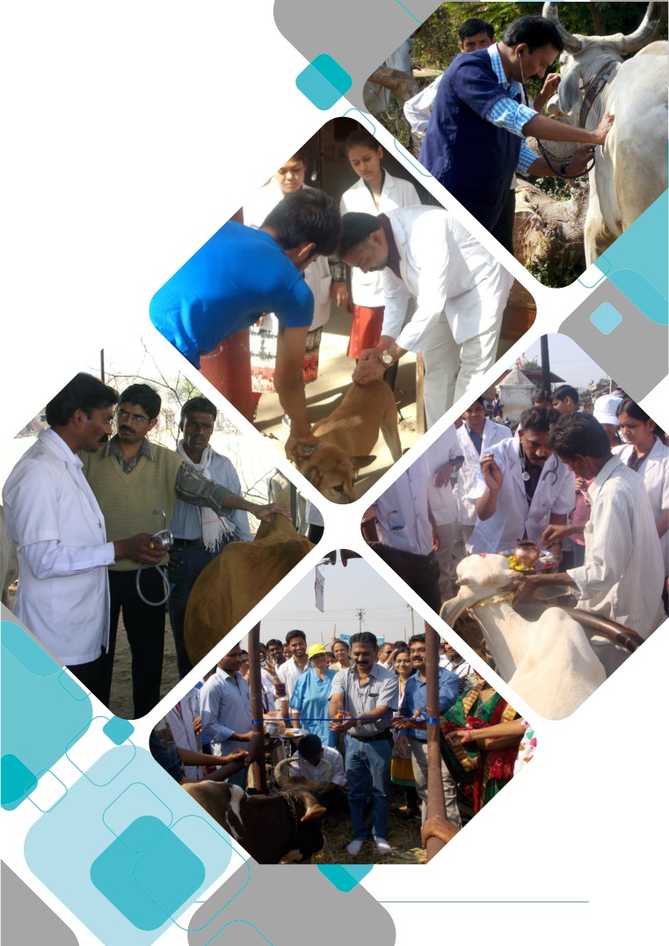

HEALTH CAMPS

22

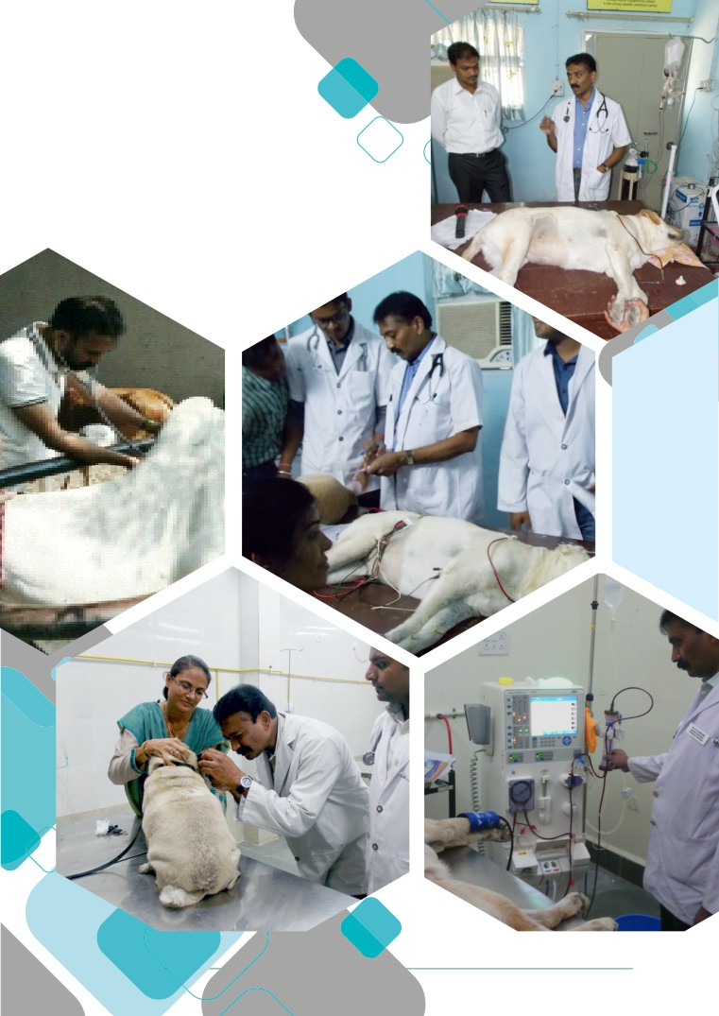

CLINICAL ACTIVITIES

23

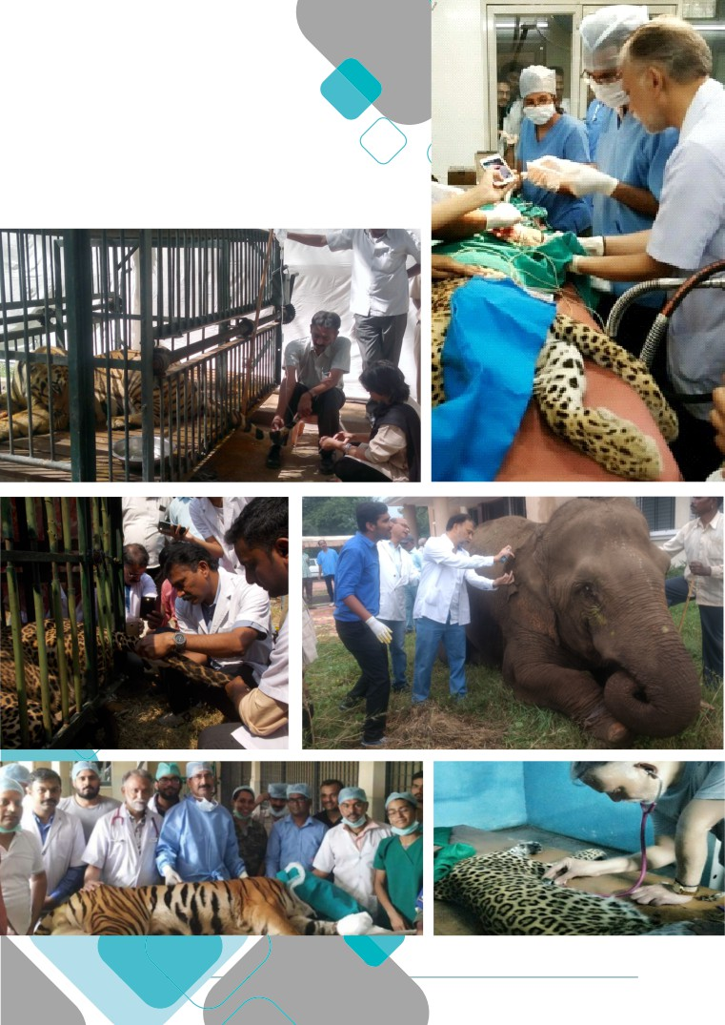

WILDLIFE ACTIVITIES

24

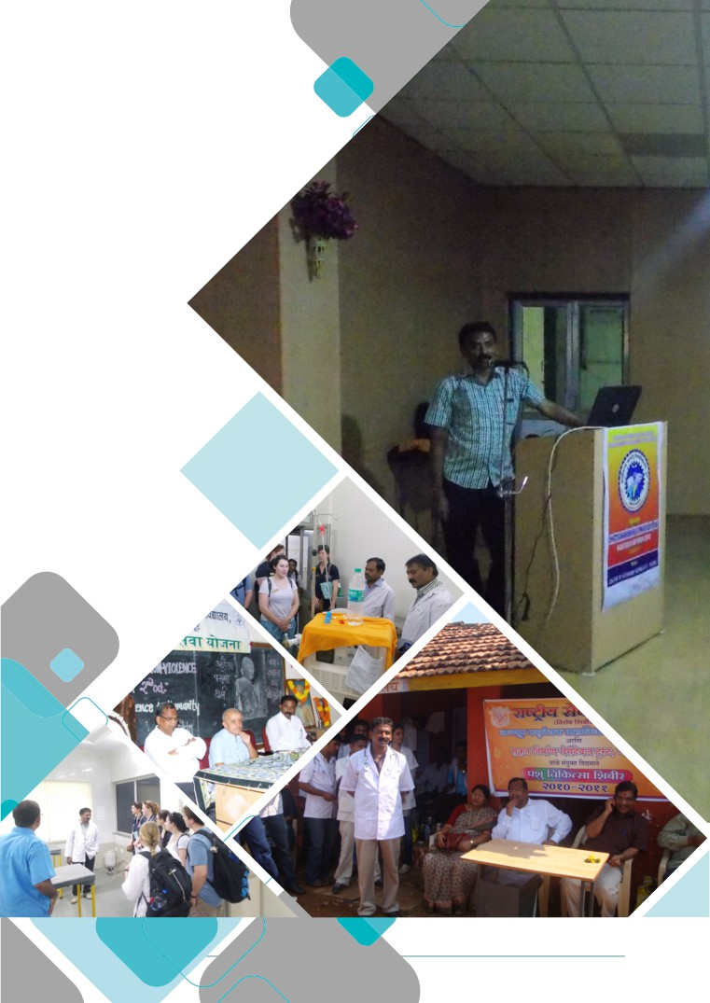

LECTURES/TRAININGS

25

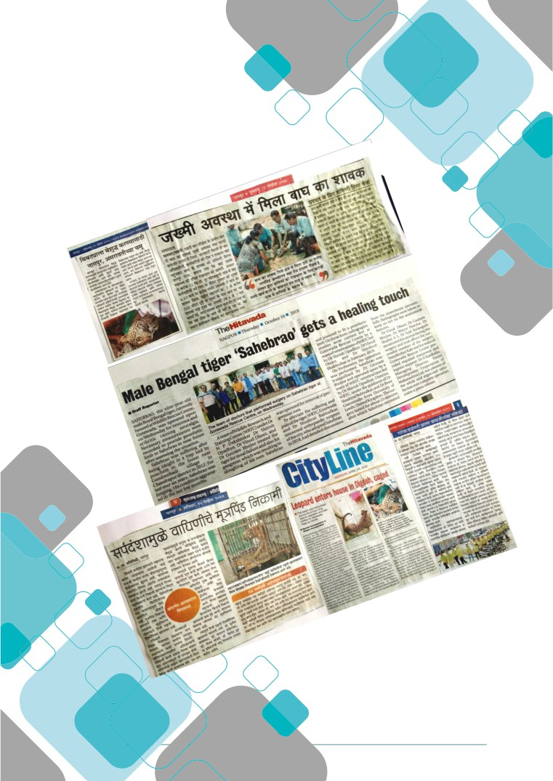

PRESS COVERAGE

26

