MAHARASHTRA ANIMAL AND FISHERY SCIENCES UNIVERSITY
NAGPUR VETERINARY COLLEGE, NAGPUR
DEPARTMENT OF VETERINARY ANATOMY AND HISTOLOGY

HISTORY OF THE DEPARTMENT:

The department of Veterinary Anatomy was the first to start in this college, after the establishment of Nagpur Veterinary College in the year 1958. It was initially in a small barrack in the premises of Government Veterinary Hospital near Maharaj Bagh. Later on, it was shifted in the year 1962 to the old college building and subsequently to the present location in the year 1968. Dr. M. K. Hawaldar, G.B.V.C. headed the department from 1958 to 1969. After his repatriation to the State department of Animal husbandary, Dr. R. V. Pandit, M.V.Sc.; Ph.D. (USA) had taken over the charge of Professor and Head. After the retirement of Dr. R. V. Pandit in the year 1992, Dr. V. R. Bhamburkar was the Professor and Head of the department and after his promotion to the post of Associate Dean, NVC, Nagpur, Dr. R. S. Dalvi became Professor and Head in the year 2003 and continued up to 2017. Since February, 2017, Dr. S. B. Banubakode is heading the department. In 1992, separate 15 departments came into existence under the faculty of Veterinary Science as per the Maharashtra Agricultural Universities Statutes 1990 prescribed under Maharashtra Council of Agricultural research and Education (MCAER), Pune by the Government of Maharashtra. Previously the institute and the Department was under the umbrella of SAU viz. Dr. Punjabrao Krishi Vidyapeeth, Akola, which was later on transferred to the 1st Veterinary University in the state and third on the national map, viz. Maharashtra Animal and Fishery Sciences University, Nagpur with effect from 3rd, December, 2000. This department has played a distinctive role in motivating the scientific community of Veterinary Anatomy fraternity in India for the cause of
- Promotion and advancement of Veterinary Anatomy
- Encouragement and stimulation to research, education and extension in Veterinary Anatomy.
- Establishment of high degree and uniform standard of Veterinary Anatomy at appropriate position in educational programme.
- Encouragement to fraternity, mutual co-operation and scientific exchanges amongst Veterinary Anatomists in India.

To achieve these goals, this department took lead in establishing the scientific society under the name “Indian Association of Veterinary Anatomists” (IAVA) in 1983, and registered this society at Nagpur with Registration No. Maharashtra/152/83/Nagpur. Since then, this department is significantly contributing and participating in the progress and development of IAVA. Another milestone in the history of this department is that since 1997, this department has become the Head quarter of IAVA with Dr. V. R. Bhamburkar, Professor and Head as Secretary and Dr. R. S. Dalvi, Associate Professor as Treasurer of the IAVA till it was shifted to Anand in 2004. The XII Annual Convention of IAVA hosted at Nagpur by this department was adjudged as the best ever convention of the IAVA held in India. The outstanding remark made by the visitors to this done by department speaks of the quality of work of this department over a period of time.

FACULTY POSITION:
Faculty | Sanctioned posts | Filled in post | Vacant | Remarks
Professor | 01 | 00 | 01
Associate professor | 02 | 02 | Nil
Assistant professor | 03 | 02 | 01
Supporting staff
Curator | 01 | 00 | 01
Lab assistant | 01 | 00 | 01
Lab attendant | 01 | 00 | 01
Sweeper | 01 | 00 | 01

FACULTY WITH QUALIFICATION:
NAME OF THE FACULTY | DESIGNATION | QUALIFICATION
Dr. S. B. Banubakode | Professor (CAS) and Head | B.V.Sc.&A.H.; M.V.Sc.; Ph.D.; F.I.A.V.A.
Dr. N. C. Nandeshwar | Professor (CAS) | B.V.Sc.&A.H.; M.V.Sc.; Ph.D.; F.I.A.V.A.
Dr. R. Y. Charjan | Assistant Professor | B.V.Sc.&A.H.; M.V.Sc.; Ph.D.;
Dr. U. P. Mainde | Assistant Professor | B.V.Sc.&A.H.; M.V.Sc.; Ph.D.;

TEACHING PROGRAMME:
1. Under Graduate -- B.V. Sc. & A.H. (MSVE 2016)
Academic year | Course | Title | Credit
I professional year | VAN | Veterinary Anatomy | 4+3=7
 |  | Total credits | 4+3=7

2. Post Graduation: M.V.Sc., Duration 2 years. Intake- 2 students/year
Course No. | Title | Credit
VAN 601 | Comparative Osteology and Arthrology | 1+2=3
VAN 602 | Comparative Splanchnology | 2+2=4
VAN 603 | Myology, Angiology, Neurology and Aesthesiology of ox | 1+3=4
VAN 604 | Gross Anatomical Techniques | 0+2=2
VAN 605 | Theory and Practice of Histological and Histochemical Techniques | 1+2=3
VAN 606 | General Histology and Ultrastructure | 3+1=4
VAN 607 | Systemic Histology and Ultrastructure | 3+1=4
VAN 608 | Developmental Anatomy | 3+1=4
VAN 691 | Master’s Seminar | 1+0=1
VAN 699 | Research | 20
3. Ph.D. : Duration 3 years. Intake- 2 students/year
Course No. | Title | Credit
VAN 701 | Myology, Angiology, Neurology and Aesthesiology of Equine, Canine and Porcine | 0+3=3
VAN 702 | Principles and Applications of Biomechanics | 2+0=2
VAN 704 | Neuroanatomy | 3+1=4
VAN 707 | Histoenzymology and Immunocytochemistry | 2+1=3
VAN 708 | Applied Embryology and Teratology | 1+2=3
VAN 709 | Functional Veterinary Anatomy | 2+0=2
VAN 791 | Doctoral Seminar I | 1+0=1
VAN 792 | Doctoral Seminar II | 1+0=1
VAN 799 | Doctoral Research | 45
 | Total credits | 45+19=64
Students awarded M.V.Sc. degree in Veterinary Anatomy and Histology:
Sr. No | Name | Guide | Year | Title
1. | Dr. J. Y. Waghaye | Dr. V. R. Bhamburkar | 1998 | Histomorphological, Histochemical & Immunohistological Studies on Some Lymphoid Organs in goat (Capra hircus)
2. | Dr. B. N. Meshram | Dr. R. S. Dalvi | 1999 | Age Related Histomorphological and Histoenzymic Changes In Pancreas of Goat
3. | Dr. S. K. Karmore | Dr. V. R. Bhamburkar | 1999 | Age Related Changes in Histomorphology and Histoenzymic Distribution in testes and epididymis in goat (Capra hircus)
4. | Dr. V. A. Patil | Dr. V. R. Bhamburkar | 2000 | Age Related Histomorphological and Histoenzymic Changes in Thyroid Gland In Relation To Anterior Pituitary In Goat
5. | Dr. A. A. Gawande | Dr. V. R. Bhamburkar | 2001 | Studies on Prenatal Development of Stomach and Intestine in Goat
6. | Dr. J.S. Tekade | Dr. R. S. Dalvi | 2001 | Studies on Prenatal Development of Gonads in Goat
7. | Dr. J.M. Hood | Dr. R. S. Dalvi | 2001 | Studies on Prenatal Development of Kidney, Ureter and Urinary Bladder in Goat
8. | Dr. A. D. Barde | Dr. R. S. Dalvi | 2002 | Comparative Neuroanatomical Studies on Olfactory Apparatus in Dog and Cat
9. | Dr.R.Y. Charjan | Dr. V. R. Bhamburkar | 2002 | Radiographic Anatomical Studies on The Fusion of Ossification Centres in The Developing Limb Bones of Different Breeds of Dog (Canis familiaris)
10. | Dr.V.H. Kadukar | Dr. S.B.Banubakode | 2003 | Radiographic Studies On The Appearance Of Ossification Centres And Fusion Of Epiphyseal Plate in The Pelvic Limb Bones of Dog
11. | Dr. M.A. Kale | Dr. V. R. Bhamburkar | 2000 | Age Related Histomorphological and Histoenzymic Changes in Adrenal Gland In Relation to Anterior Pituitary in Goat
12. | Dr. U.P. Mainde | Dr. N.C. Nandeshwar | 2007 | Studies on Prenatal Development of Thymus in Goat (Capra hircus)
13. | Dr. B. A. Zade | Dr. O.N. Ladukar | 2007 | Age Related Histological & Histochemical Changes in Testis of Dog (Canis Famillaris)
14. | Dr. S. S. Bodkhe | Dr. S. B. Banubakode | 2006 | Histochemical Changes During Histogenesis of Thymus in Chicken Embryo of RIR Layers (Gallus gallus domesticus )
15. | Dr. H.S. Gabhane | Dr. N.C. Nandeshwar | 2008 | Histomorphogical and Histochemical Study On Lymphoid Tissue In The Alimentary Tract Of Goat (Capra hircus)
16. | Dr. D.E. Gaykee | Dr. S. B. Banubakode | 2008 | Differentiation of Spotted Deer from Domestic Ruminants by PCR Technique
17. | Dr. R.U.Gajbe | Dr. S. B. Banubakode | 2009 | Identification of Domestic Animals By PCR Technique
18. | Dr. A.M. Salankar | Dr. S. B. Banubakode | 2010 | Identification of some carnivore animals by PCR technique
19. | Dr. P.M. Gedam | Dr. N.C. Nandeshwar | 2010 | Histomorphological and Histochemical Studies on Instestinal Lymphoid Tissues in Kadaknath Breed of Poultry. (Gallus gallus domesticus)
20. | Dr. S. Sathapathy | Dr. R. S. Dalvi | 2013 | Histological and histochemical studies on angioarchitecture of coronary artery in goat (Capra hircus)
21. | Dr. S. P. Khandate | Dr. N.C. Nandeshwar | 2013 | Histological and histochemical studies on angioarchitecture of femoral artery in goat (Capra hircus)
22. | Pawan Kawareti | Dr. N.C. Nandeshwar | 2016 | Gross anatomical and morphometrical studies on hooves in equines (Equus caballus) on different age groups

Students awarded Ph.D. degree in Veterinary Anatomy and Histology:
Sr. No | Name | Guide | Year | Title
1. | Dr. R.S. Dalvi | Dr. R.V. Pandit | 1982 | Study of anatomy of stifle joint complex in domestic ruminants
2. | Dr. O. N. Ladukar | Late Dr. R. V. Pandit | 1991 | Neuro –anatomical study of buffalo (Bubalus bubalis, Linne) Pancreas
3. | Dr.S.B. Banubakode | Dr.V.R. Bhamburkar | 1999 | Histological,Histochemical & Immunohistological changes in oviduct & uterus during different phases of estrus cycle & early pregnancy in goat
4. | Dr.N.C. Nandeshwar | Dr.V.R. Bhamburkar | 2002 | Histomorphological, Histochemical & Immunohistological Studies on some Endocrine Organs of Goat (Capra hircus)
5. | Dr. J. Y. Waghaye | Dr.V.R. Bhamburkar | 2007 | Histological and Histochemical Changes in Ovary During Different phases of oestrus cycle in goat
6. | Dr. B. N. Meshram | Dr. R.S. Dalvi | 2008 | Electron Microscopic and Histoenzymatic studies on Pancreatic Islets In Goat
7. | Dr. S. K. Karemore | Dr. R.S. Dalvi | 2008 | Electron Microscopic and Histoenzymatic Studies on the Testis and The Extra Testicular Duct System of Goat
8. | Dr. Durga Chaurasia | Dr. R.S. Dalvi | 2011 | Histochemical and Ultrastructural Studies on Mammary Gland in Buffalo (Babalus bubalis)
9. | Dr. A. M. Salankar | Dr. R.S. Dalvi | 2016 | Histological and histochemical studies on cerebrum, cerebellum, pons and medulla oblongata in goat (Capra hircus).
10. | Dr. P.M Gedam | Dr. N.C. Nandeshwar | 2016 | Histomorphological and Histochemical studies on gut associated lymphoid tissue of Khaki Campbell breed of duck(Anas platyrhynchos)
11. | Dr.Jigyasa Rana | Dr. S. B. Banubakode | 2018 | Histogenesis of Harderian gland in chicken
12. | Dr. U.P. Mainde | Dr.S.B.Banubakode | 2019 | Histological, Ultrastructural and Histochemical Studies on Skin in Goat (Capra hircus)
13. | Dr. R. Y. Charjan | Dr. N.C. Nandeshwar | 2020 | Trichology of domestic and wild animals: A forensic evidence.

LIST OF EQUIPMENTS TO BE MADE AVAILABLE FOR ESTABLISHMENT OF VETERINARY COLLEGE

Sl. No. | PRESCRIBED EQUIPMENTS (with its quantity) | REQUIRED | AVAILABLE QUANTITY | Date of purchase with delivery challan No. & date | Book No., Entry No., & Page No. of Stock book entry | Remarks
VETERINARY ANATOMY

1. | Almirah for bones, microscope etc. | As per need | 13  1 | Received from Associate Dean Office  Dt. 13/08/1966  29/03/2003  Challan No. PF/03/220  Dt. 29/03/2003 | Dead Stock Register No.2  Pg. No. 3,4  No. of Stock book entry 1to6.  Dead Stock Register No.2  Pg. No. 04  No. of Stock book entry 8.
2. | Steel or Iron racks for bones | 15 | 24 | Received from Nagpur Veterinary College Library on March 2010 | ----
3. | Show-cases (glass paneled) for museum | 15 | 04  08 | 10/10/1960  Challan No. 60  Dt. 10/10/1960  Received from Nagpur Veterinary College Library on August 2021 | Dead Stock Register No.2  Pg. No. 10  No. of Stock book entry 1 &2
4. | Marble-top or S.S Top tables (with drainage)- for dissection | 10 | 24  3 | 06/09/1963  Challan No. 13072  Dt. 06/09/1963  13/08/1968  Challan No. 11434  Dt. 13/08/1968 | Dead Stock Register No.1  Pg. No. 79  No. of Stock book entry T/1 & 2.
5. | Compound microscopes | 30 | 25 | 15/06/2011 transferred from Department of Veterinary Pathology | Dead Stock Register No.2  Pg. No. 20  No. of Stock book entry 27a.
6. | Binocular microscopes | 10 | 10  1 | 30/03/2007  Challan No. 523  Dt. 30/03/2007  13/03/2008  Challan No. 134 B  Dt.28/03/2008 | Dead Stock Register No.2  Pg. No. 17  No. of Stock book entry 24.  Dead Stock Register No.2  Pg. No. 20  No. of Stock book entry 27.
7. | Autoclave | 1 | Nil
8 | P ^{H} meter | 1 | 1 | 31/03/2017  Challan No. 792  Dt. 31/03/2017 | Dead Stock Register No.2  Pg. No. 29  No. of Stock book entry 41.
9. | Hot air oven | 2 | Nil
10. | CCTV attachment for Microscope | 1 | 1 | 13/03/2017  Challan No. 792  Dt. 31/03/2017 | Dead Stock Register No.2  Pg. No. 29  No. of Stock book entry 1.
11. | Cadaver injector | 1 | 1 | 31/03/2017  Challan No. 00276  Dt. 31/03/2017 | Dead Stock Register No.2  Pg. No. 30  No. of Stock book entry 44.
12. | Deep freezer - -20⁰ c - Horizontal | 1 | 1 | 17/08/2021  Challan No. 02  Dt. 17/08/2021 | Dead Stock Register No.3  Pg. No. 19  No. of Stock book entry---.
13. | Digital Analytical balance | 1 | 1  1 | 31/03/2017  Challan No. 00275  Dt. 31/03/2017  26/03/2003  Challan No. 314  Dt. 26/03/2003 | Dead Stock Register No.2  Pg. No. 28  No. of Stock book entry 39.  Dead Stock Register No.1  Pg. No. 09  No. of Stock book entry 26.
14. | X- ray viewer | 2 | Nil
15. | Slide warmer | 2 | 1 | 26/03/2003  Challan No. 314  Dt. 26/03/2003 | Dead Stock Register No.1  Pg. No. 78  No. of Stock book entry 58.
16. | Semiautomatic or Automatic rotary microtome | 2 | 1 | 24/04/2000  Challan No. KN-067  Dt. 24/04/2000 | Dead Stock Register No.1  Pg. No. 96  No. of Stock book entry 1A.
17. | Tissue floatation bath | 2 | 1 | 31/03/2017  Challan No. 00275  Dt. 31/03/2017 | Dead Stock Register No.2  Pg. No. 28  No. of Stock book entry 40.
18. | Histoembedder | 1 | 1 | -- | ---
19. | Refrigerator (double door) | 1 | 1 | 22/03/2012  Challan No. 8977  Dt. 22/03/2012 | Dead Stock Register No.2  Pg. No. 26  No. of Stock book entry 37.
20. | Drilling machine for skeleton mounting | 2 sets | 1 | 16/09/1991  Challan No. 71686  Dt. 16/09/1991 | Dead Stock Register No.1  Pg. No. 89  No. of Stock book entry 1.
21. | Electric bone saw | 1 | 1 | 21/12/2005  Challan No. At/05-06/026  Dt. 21/12/2005 | Dead Stock Register No.1  Pg. No. 25  No. of Stock book entry 25.
22. | Animal hoisting unit with hooks etc. | 1 | 2 | --- | ---
23. | Post mortem sets | 2 | 1  1 | 07/02/1961  Challan No. 60310  Dt. 07/02/1961  06/03/1961  Challan No. 2933-60  Dt. 06/03/1996 | Dead Stock Register No.1  Pg. No. 32  No. of Stock book entry I/1.  Dead Stock Register No.1  Pg. No. 33  No. of Stock book entry I/3.
24. | Scissors Straight | As per need | 07 | Purchased under RFS on September 2021
25. | Scissors Curved | As per need | 07
26. | Hand saw | As per need | 02
27. | Rib cutter | As per need | 07
28. | Forceps Large | As per need | 07
29. | Forceps small | As per need | 07
30. | Artery forceps | As per need | 07
31. | B. P Handles | As per need | 07
32. | Tennaculum | As per need | Not required

ACHIEVEMENT ACCREDITED TO THE DEPARTMENT

The department has a well developed set up of laboratory as per the norms of Veterinary Council of India. There is a separate dissection hall with stainless steel top dissection tables provided with cooling facility. This hall has been partitioned into two subdivisions one for dissection of locomotor system including biomechanics and arthrology and myology and the other for splanchnology. Both units are well ventilated and well lighted. A batch of 20 students can be accommodated for dissection at a time. The Osteology laboratory has skeletons of all the domestic as well as few wild animals and is having more than 10 sets of loose bone for students study purpose. The department has created air conditioned unit having facility of phase contrast and stereoscopic microscopes (Nikon, Japan) with CCD camera along with display system of set of 10 monitors and LCD projector for demonstration of histology slides. This facility is extended under FIST programme of DST, New Delhi. The third laboratory is the Hi-Tech research laboratory. The department has created a Molecular Anatomy Laboratory, which unique of its kind in India. This facility is useful for identification of species of animals from remains, which are being collected from the site of poaching. All necessary equipment viz. PCR, electrophoresis, refrigerated centrifuge machine, research microscope, cryostat, PH meter, chemical balance, triple glass distillation apparatus, automatic tissue processing unit, automatic staining machine, microtome etc. are available in this laboratory. All glassware and chemicals are provided as per requirement to P. G. and Ph.D. students.

RESEARCH PROGRAMME

In addition to post-graduate research programme, the department conducts departmental research work under the ASRC program of University. Under this program, department has completed till now 15 small projects of applied importance mostly for the benefit of field workers and animal keepers for instance:
1. Study of sacral epidural space to estimate optimum doses for caudal epidural anaesthesia in cattle. Results indicate that in non descript Indian cattle, volume of epidural space is 4.5 to 6.0 cu cm. It is, therefore, estimated that 4 to 6 ml anaesthetic is required.
2. Per cutaneous approach for stimulation or blockade of coeliaco-mesenteric plexus and ganglion in ruminants. The exact location of coeliaco-mesenteric plexus is determined as just behind the head of last rib, which could be approached for giving Intra-abdominal medication, while treating certain diseases of gastro-intestinal tract in ruminants.
3. Osteometric study of Hip joint in cattle.
Care should be taken to avoid slip of hip joint in cross-bred animals in cattle sheds because of the shallowness and greater surface area of acetabulum.
4. Comparative study of sweat glands distribution in the skin of rabbit.
The sweat glands in rabbit skin are superficial in location and do not participate in the thermoregulation mechanism. Hence, during heat stress artificial cooling system should be provided to rabbits to avoid mortality.
5. Identification of domestic and wild animal by PCR technique

ICAR / DBT Research Projects:
The department is running research project funded by ICAR as under.
1. Revolving Fund scheme entitled “Application of Anatomical techniques for preparation of Veterinary Anatomy teaching aids” (Completed)

2. NATP Project on “Draft power assessment of different breeds of cattle and buffalo”
(Completed). The department has published and presented more than 150 papers in scientific conventions / National symposia. This department has an honour of organizing the XII Convention of Indian Association of Veterinary Anatomists and National Symposium in Veterinary Anatomy during the year 1997.
3. FIST: sponsored by S&T, DBT, New Delhi

EXTENSION ACTIVITIES:

- The academic staff of the department regularly participates in the training programmes conducted by the college for unemployed youths, school students and small farmers. A beautiful museum has been developed by the department, which has been appreciated by the dignitaries and visitors.
- This department has run innovative ICAR Revolving Fund Scheme, through which anatomy laboratory materials such as mounted skeletons, organ specimens, and other teaching aids were prepared and supplied to other institutes. Participation of staff in TV telecast and Radio programmes for awareness of farmers and animal lovers on Veterinary Anatomical aspects.
- Departmental staff is engaged in continued education programme for field veterinarian.

OTHER RELEVANT ACTIVITIES:
1. Resource Generation Scheme
Earned more than Rs. 25 lakhs under "Resource Generation Scheme" of the Department. Since starting, Educational material such as Histological slides, Skeleton and Gross Anatomy chart supply to various colleges and institutes in India.

2. The Department has rendered consultancy services to
1) Department of Forest (Wildlife), Government of Maharashtra
2) Geological Survey of India
3) Archeological Survey of India
4) Police Department
FUTURE PROSPECTIVE FOR DEVELOPMENT OF DEPARTMENT:
- Digitization of Anatomy laboratory.
- Creation of cold room facility.
- Alternatives in Anatomy.
- Development of National level Osteology Museum
- Development of Molecular anatomy laboratory for identification of species.

(PROFESSOR AND HEAD)
Laboratory Facilites

Mounted skeletons

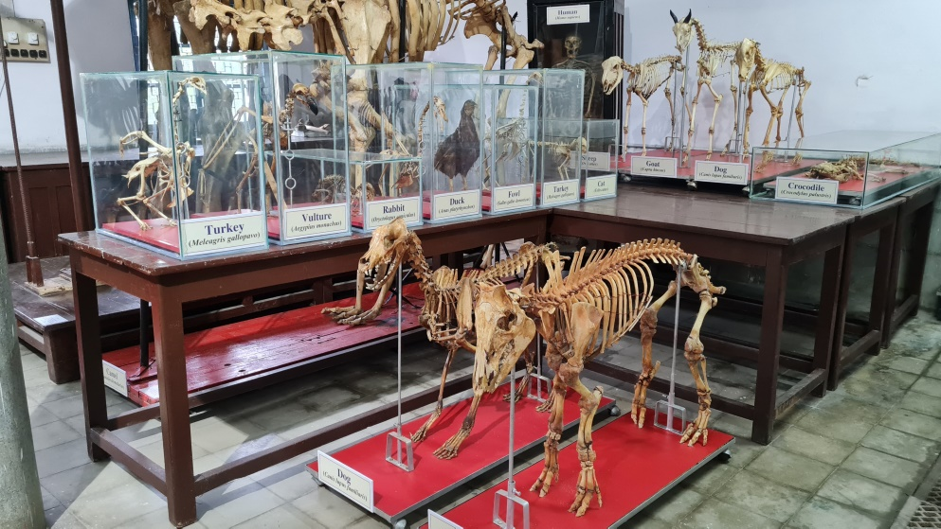
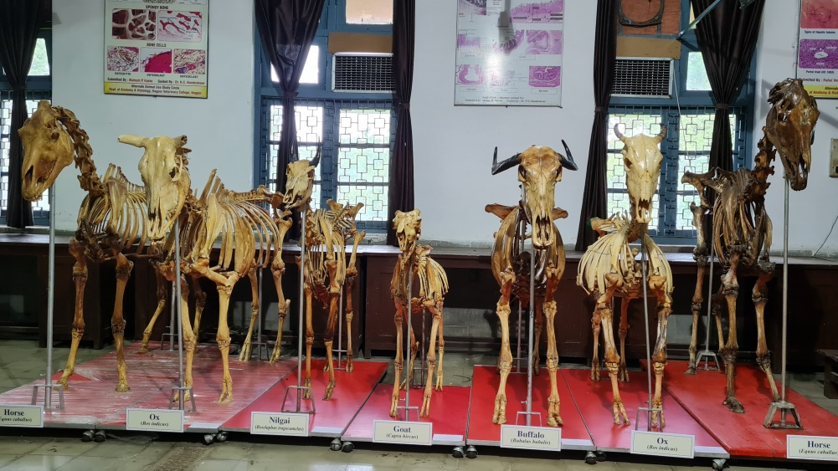
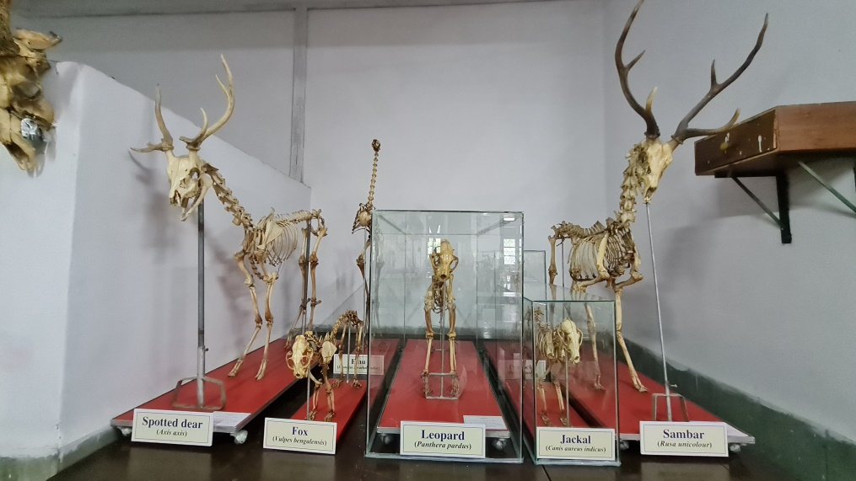
STUDY BONES FOR STUDENTS

Loose Bone

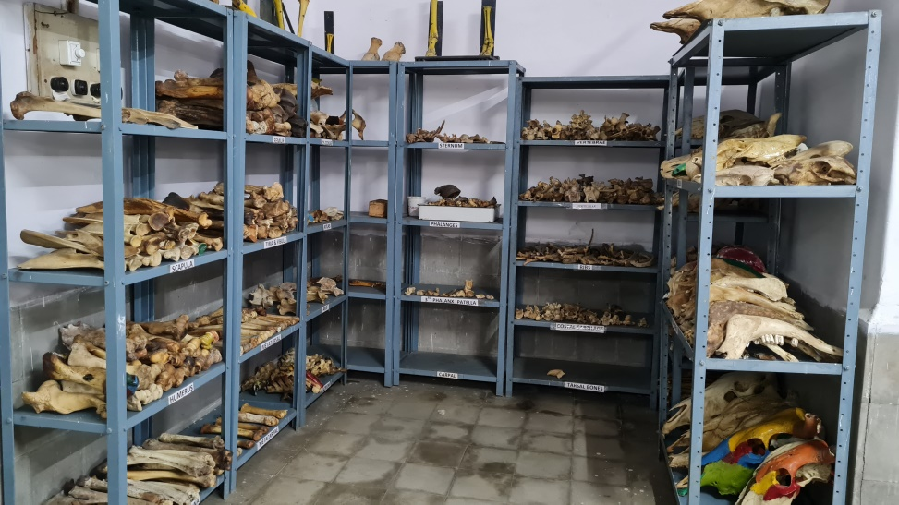

Mounted bones

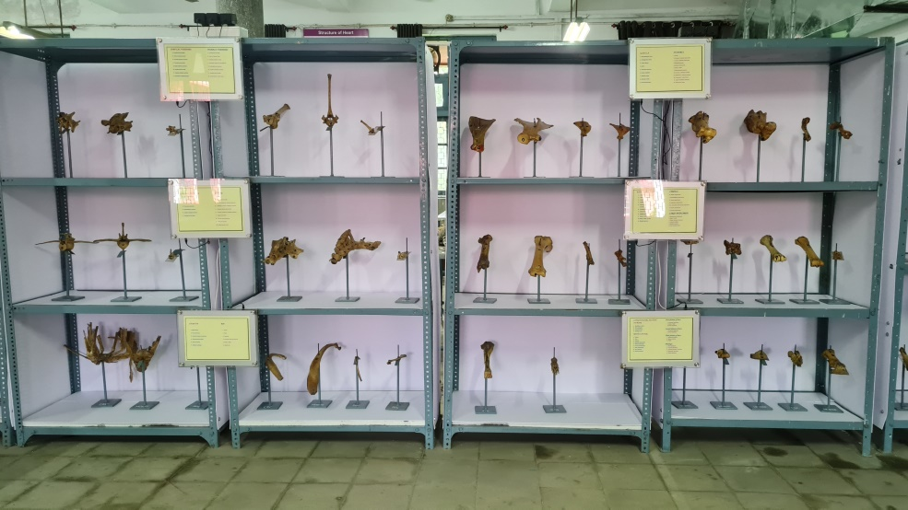

SPLANCHNOLOGY SPECIMENS FOR STUDENTS

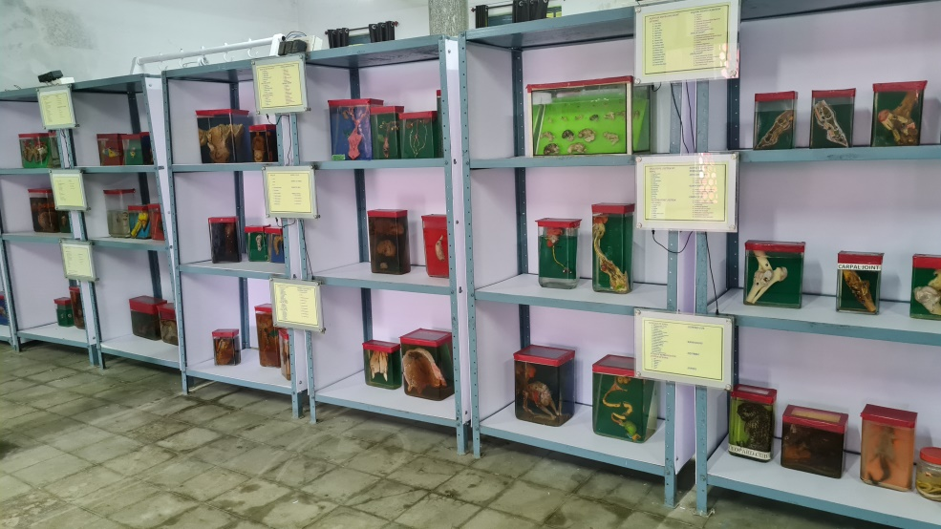

DEPARTMENT PASSAGE

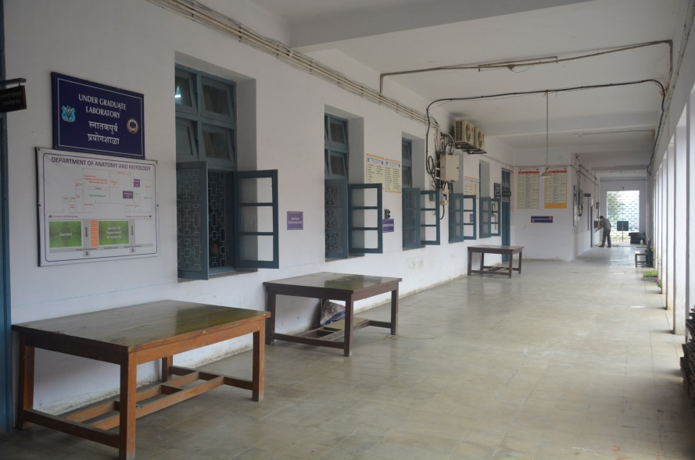

DIST-FIST Sponsored Programme Histology Laboratory

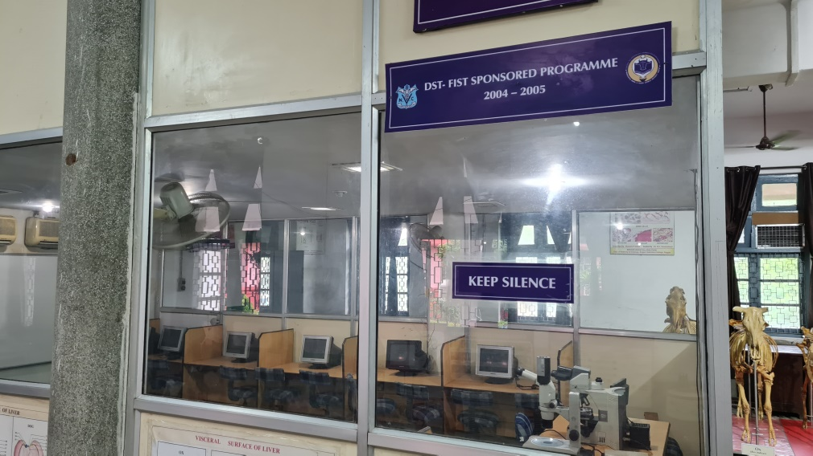

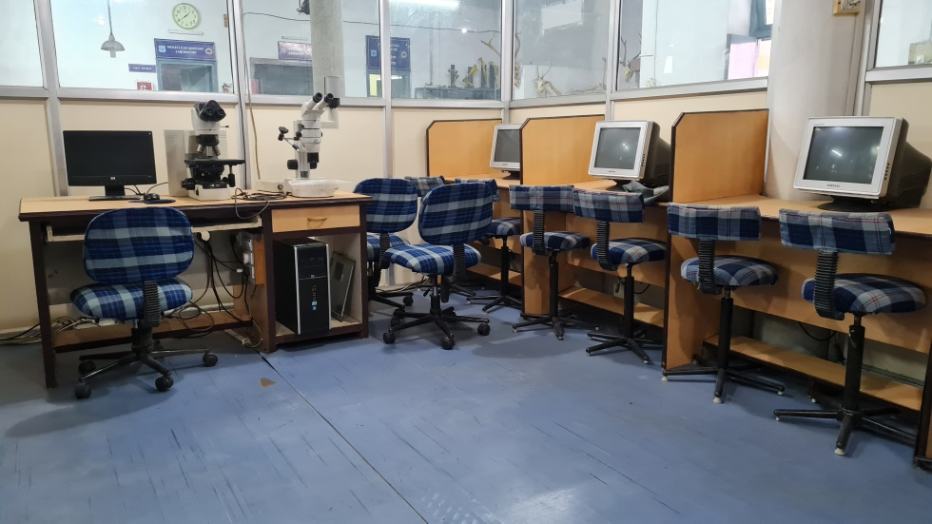

MOLECULAR ANATOMY LABORATORY
Developed with funds generated under REVOLVINF FUND SCHEME
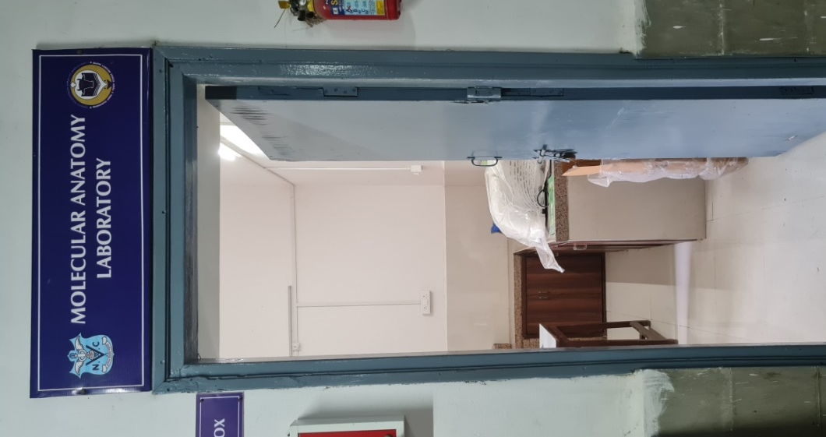
EQUIPMENTS OF MOLECULAR LABORATORY
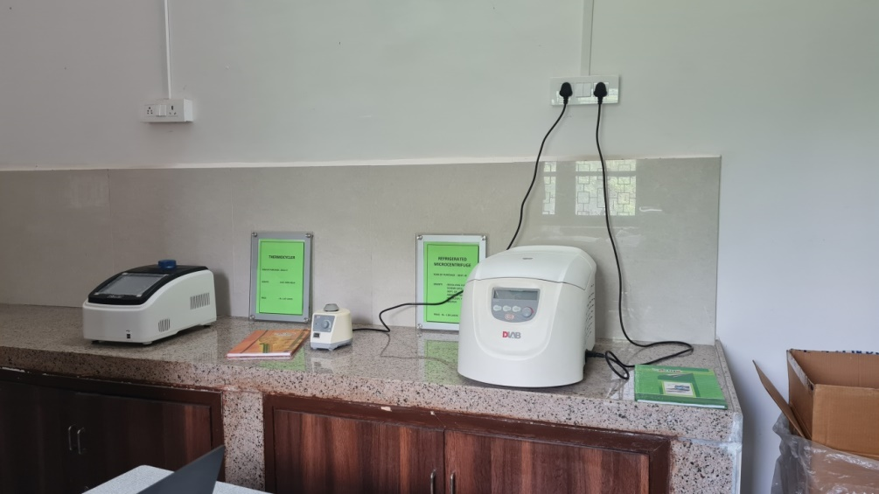

DEPARTMENT GARDEN
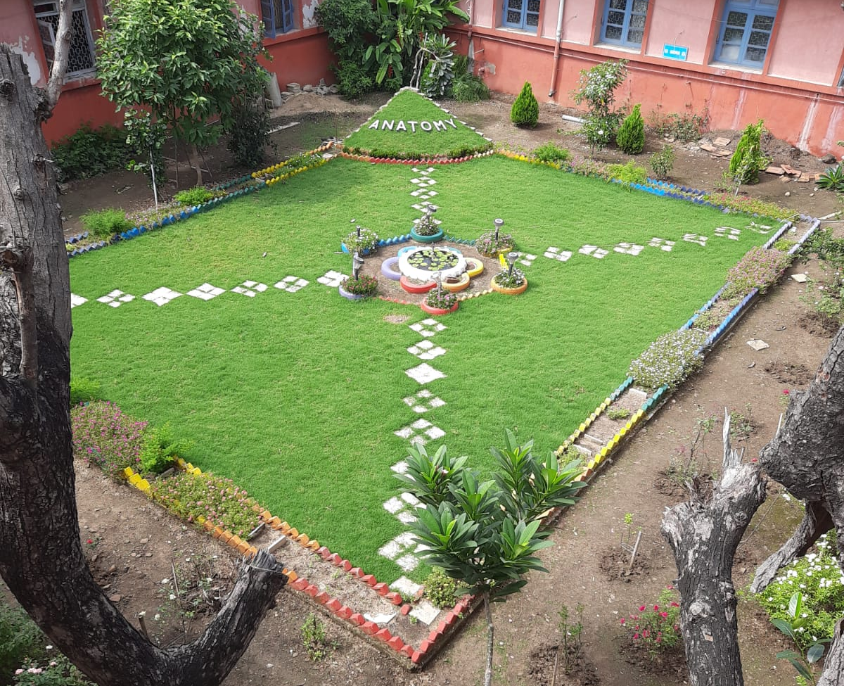

MAHARASHTRA ANIMAL AND FISHERY SCIENCES UNIVERSITY, NAGPUR
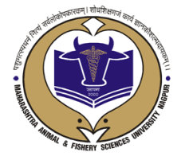

STATUS REPORT
OF
DEPARTMENT OF VETERINARY ANATOMY AND HISTOLOGY
NAGPUR VETERINARY COLLEGE, NAGPUR

Excerpts
MOHAN BHAGWAT
Molecular lab photo
Garden photo
Board of visitors

